**Animal Shelter Database System Project**

**Project Objective:**

Organizing tons of data in every organization is important to effectively manage operations and streamline processes. QUELIFE is an animal shelter organization for which we will be designing a database system. This organization has multiple branches spread across Wisconsin, Illinois, Missouri, Montana, California, Texas, and Nevada. This database will encompass primary details related to facilities, animal descriptions and transfer details, sponsor details and employee details.

**Requirement Analysis:**

We are analysing the requirements to setup a database for this organization. We have multiple entities to consider along with their relationships. Here we have multiple branches of shelter at multiple locations with various facilities. Animal related records including animal information, animal features, adoption records and surrender details are need as well as the history of each animal. We are enabling the option to transfer of animals from one branch to another. Employee details, sponsor details and payment details are required to track the working of the shelter.

**Assumptions:**

1. Animals can be transferred from one branch to another
2. Each shelter branch will have multiple employees
3. Each shelter branch will have a branch manager
4. Employees work only in one shelter branch only (no transfer of employees)
5. An animal can be adopted as well as surrendered to the shelter for various reasons multiple times
6. A vaccination is given each time an animal is detected with any disease
7. Sponsors can support multiple shelter branches
8. Full payment must be done in a single payment for adoption of an animal
9. Each medical condition of an animal is treated by only one veterinarian
10. Veterinarians can treat multiple conditions of multiple animals
11. Each transfer of an animal involves transfer from one branch to another
12. Each veterinary doctor can have multiple specializations
13. All contacts should not contain spaces

**Entities and Relationships:**

1. **shelter_branch:**
   * Entity Description: This entity contains details about the geographic location and details of each branch
   * Attributes: shelter_id, shelter_name, address, pin code, shelter_contact
   * Relationships:
     + One-to-one relationship with facilities
     + Many-to-many relationship with animal_info
     + One-to-many relationship with employees_staff_details
     + Many-to-many relationship with animal_transfer_records
     + Many-to-many relationship with sponsor
2. **facilities:**
   * Entity Description: This entity represents amenities operated by each branch.
   * Attributes: fid, f_capacity, f_ani_count, f_area, play_areas, temp_control, outdoor_space
   * Relationships:
     + One-to-one relationship with shelter_branch
3. **animal_info:**
   * Entity Description: This entity contains information about the animal.
   * Attributes: animal_id, a_type, a_breed, a_dob, date_of_acquisition, a_vaccine_status.
   * Relationships:
     + Many-to-many relationship with shelter_branch (as we have transfer facility)
     + One-to-one relationship with animal_features
     + Many-to-many relationship with surrender_details
     + Many-to-many relationship with adoption_details
     + One-to-many relationship with animal_transfer_records
     + Many-to-many relationship with nutrition
     + Ternary relationship with history of the animal which includes: grooming history, training history and medical history
4. **animal_features:**
   * Entity Description: This entity contains physical attributes of the animal.
   * Attributes: animal_id, a_color, a_weight, a_height, a_eye_color, a_condition
   * Relationships:
     + One-to-one relationship with animal_info
5. **adoption_details:**
   * Entity Description: This entity contains information about the adoption of an animal
   * Attributes: ad_ID, animal_id, ad_name, ad_contact, ad_date, ad_fee.
   * Relationships:
     + Many-to-many relationship with animal_info
     + One-to-one relationship with payment_details
6. **surrender_details:**
   * Entity Description: This entity contains details about returning of the animal to the shelter
   * Attributes: s_id, s_date, s_name (person who brings animals), s_reason.
   * Relationships:
     + Many-to-many relationship with animal_info
7. **nutrition:**
   * Entity Description: This contains information about diet and nutrition of each animal
   * Attributes: food_id, food_type, food_quantity
   * Relationships:
     + Many-to-many relationship with animal_info
8. **training_history:**
   * Entity Description: This entity contains details about training the animals
   * Attributes: training_ID, trainer_name, training_date, training_type, training_stage.
   * Relationships:
     + Many-to-one relationship with animal_info
     + Many-to-many relationship with employees_staff_details
9. **grooming_history:**
   * Entity Description: This entity contains details about grooming the animals
   * Attributes: grooming_id, groomer_name, grooming_date, grooming_type.
   * Relationships:
     + Many-to-one relationship with animal_info
     + Many-to-many relationship with employees_staff_details
10. **medical_history:**
    * Entity Description: This entity contains details about the medical history of each animal
    * Attributes: medical_id, animal_id, disease, vet_id, treatment_date, vaccination_id
    * Relationships:
      + Many-to-one relationship with animal_info
      + Many-to-many relationship with vet_id
      + One-to-one relationship between medical_history and vaccination
11. **vaccination:**
    * Entity Description: This entity contains details about the vaccination of each animal
    * Attributes: vaccination_id, vaccination_name, vaccination_date, vaccination_dosage
    * Relationships:
      + One-to-one relationship between medical_history and vaccination
12. **employees_staff_details:**
    * Entity Description: This entity contains details about each worker or employee at the animal shelter QUELIFE
    * Attributes: emp_id, emp_name, emp_level, emp_contact, emp_department, emp_training, emp_education, emp_criminal_record
    * Relationships:
      + Many-to-one relationship with shelter_branch
      + Many-to-many relationship with grooming_history
      + Many-to-many relationship with training_history
      + Unary relationship – manages – branch manager
13. **sponsor:**
    * Entity Description: This entity contains details about sponsors given to shelter_branch
    * Attributes: sponsor_id, sponsor_name, sponsor_contact, sponsorship_type.
    * Relationships:
      + Many-to-many relationship with shelter_branch
      + One-to-many relationship with payment_details
14. **payment_details:**
    * Attributes: payment_ID, amount, payment_Date, payment_type.
    * Relationships:
      + One-to-one relationship with adoption_details
      + Many-to-one relationship with sponsor
15. **veterinary:**
    * Entity Description: This entity contains details of the veterinarian
    * Attributes: vet_id, vet_name, vet_contact, education, specialization, work_exp
    * Relationships:
      + Many-to-many relationship with medical_history
16. **animal_transfer_records:**
    * Entity Description: This entity contains details of transfer of animals from one branch to another
    * Attributes: transfer_id, transfer_date, transfer_from, transfer_to, animal_id.
    * Relationships:
      + Many-to-one relationship with animal_info
      + Many-to-many relationship with shelter_branch
17. **employee_payroll:**
    * Entity Description: This entity contains details of the working hours of each employee.
    * Attributes: swipe_id, swipe_date, check_in_time , check_out_time, hourly_pay
    * Relationships:
      + Many-to-one relationship with employees_staff_details

**Relationship Summary:**

|  |  |  |  |
| --- | --- | --- | --- |
| **Entities** | **Degree of Relationship** | **Relationship type** | **Relation name** |
| animal_info - animal_features | Binary | One-to-one | has |
| animal_transfer_records - animal_info | Binary | Many-to-one | record |
| grooming_history - employees_staff_details | Binary | Many-to-many | perform |
| nutrition - animal_info | Binary | Many-to-many | need |
| shelter_branch - facilities | Binary | One-to-one | will_have |
| shelter_branch - animal_info | Binary | Many-to-many | accommodate |
| shelter_branch - employees_staff_details | Binary | One-to-many | employ |
| shelter_branch - animal_transfer_records | Binary | Many-to-many | tranfers |
| sponsor - shelter_branch | Binary | Many-to-many | support |
| sponsor - payment_details | Binary | One-to-many | pays |
| surrender_details - animal_info | Binary | Many-to-many | submit |
| training_history - employees_staff_details | Binary | Many-to-many | done_by |
| veterinary - medical_history | Binary | Many-to-many | examines |
| animal_info - adoption_details | Binary | Many-to-many | contains |
| medical_history - vaccination | Binary | One-to-one | include |
| payment_details - adoption_details | Binary | One-to-one | require |
| employee_payroll - employees_staff_details | Binary | Many-to-one | pays |
| employees_staff_details | Unary | One-to-many | branch_manager_of |
| animal_info - training_history | Ternary | One-to-many | stores |
| animal_info - grooming_history | One-to-many |
| animal_info - medical_history | One-to-many |

**E-R Diagram:**

Entity-Relationship Diagram of the Animal Shelter Database System:

Link for higher resolution: [E-R Diagram using Miro](https://miro.com/app/board/uXjVNsDdN1s=/?share_link_id=92231814360)



Updated Entity-Relationship Diagram

**SCHEMA: (Primary Key: Underlined, Foreign Key: Italics)**

shelter_branch (shelter_id, shelter_name, shelter_loc, pincode, shelter_contact)

animal_info (animal_id , a_type, a_breed, a_dob, date_of_acquisition, a_vaccine_status, *animal_features_id* )

animal_features (animal_features_id, a_color, a_weight, a_height, a_eye_color, a_condition)

animal_transfer_records (transfer_id, transfer_date, transfer_from, transfer_to, *animal_id*)

grooming_history (grooming_id, groomer_name, grooming_date, grooming_type)

nutrition (food_id, food_type, food_quantity)

sponsor (sponsor_id, sponsor_name, sponsor_contact, sponsorship_type)

surrender_details (s_id, s_date, s_name, s_reason)

training_history (training_ID, trainer_name, training_date, training_type, training_stage)

veterinary (vet_id, vet_name, vet_contact, education, work_exp)

vet_specialization(*vet_id*, specialization)

medical_history (medical_id, disease, *vaccination_id*, treatment_date)

payment_details (payment_ID, *sponsor_id* , amount, payment_Date, payment_type)

employees_staff_details (emp_id, emp_name, emp_level, emp_contact, emp_department, emp_training, emp_education, emp_criminal_record, emp_salary, *shelter_id*, manager_emp_id)

facilities (facilities_id, *shelter_id* , f_capacity, f_ani_count, f_area, play_areas, temp_control, outdoor_space)

adoption_details (ad_ID, *payment_ID*, ad_name, ad_contact, ad_date, ad_fee)

vaccination (vaccination_id, vaccination_name, vaccination_date, vaccination_dosage)

employee_payroll (swipe_id, *emp_id*, swipe_date, check_in_time, check_out_time, hourly_pay)

perform *(grooming_id, emp_id)*

examines *(vet_id, medical_id)*

support *(shelter_id, sponsor_id)*

contain (*animal_id, ad_ID)*

need (*food_id, animal_id)*

submit (*s_id, animal_id)*

accommodate (*shelter_id, animal_id)*

transfers (*shelter_id, transfer_id)*

done_by *(training_ID, emp_id)*

stores (animal_info_id, training_history_id, grooming_history_id, medical_history)

**SCREENSHOTS OF TABLE CREATION AND VALUE INSERTIONS:**

**Creating a table named sponsor**

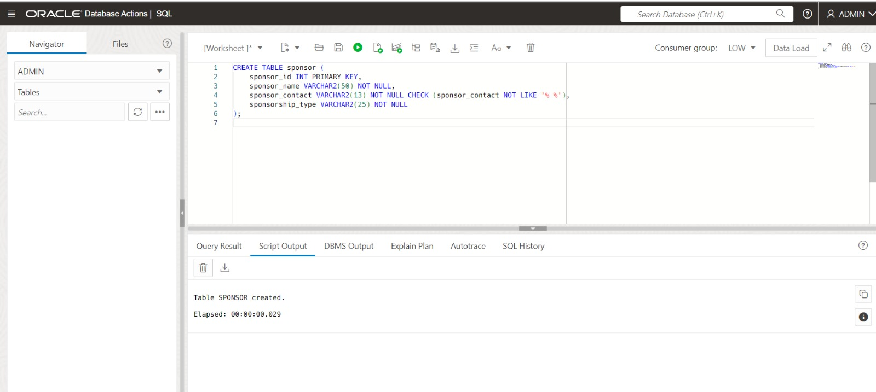

**Inserting values to sponsor**

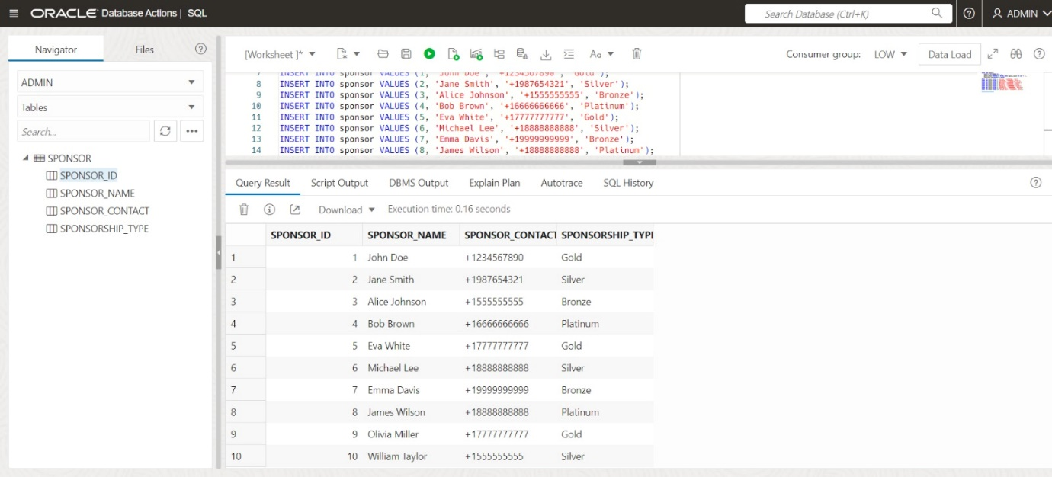

**Creating a table named veterinary**

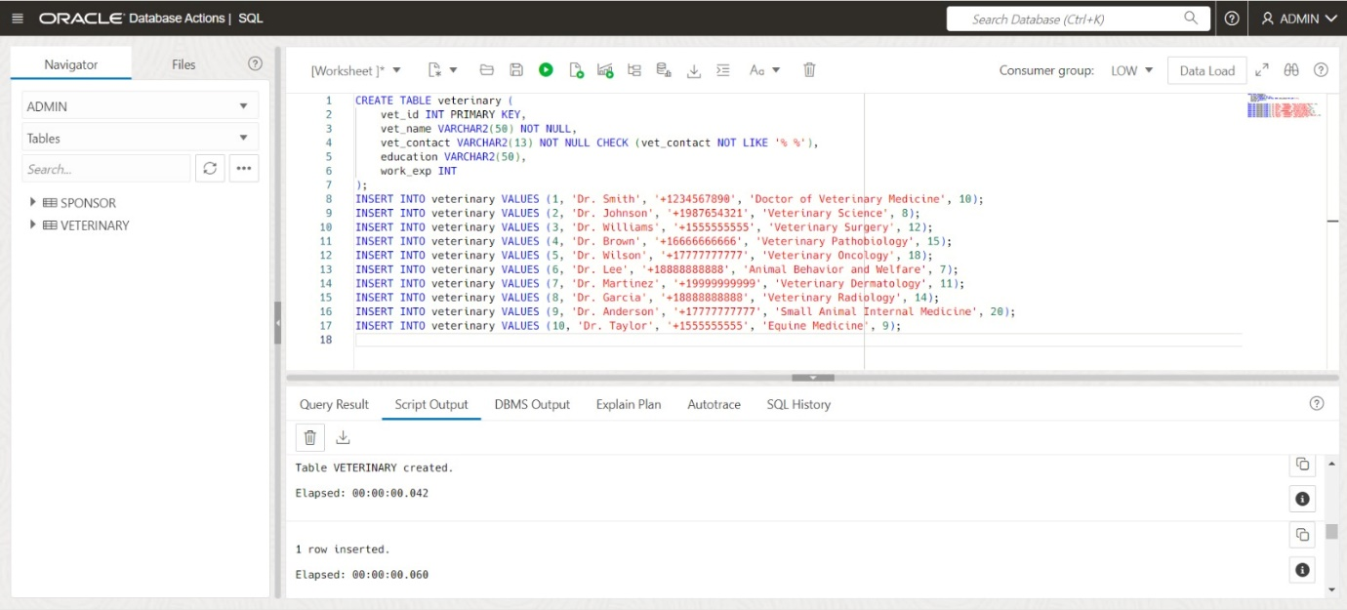

**Inserting values to veterinary**

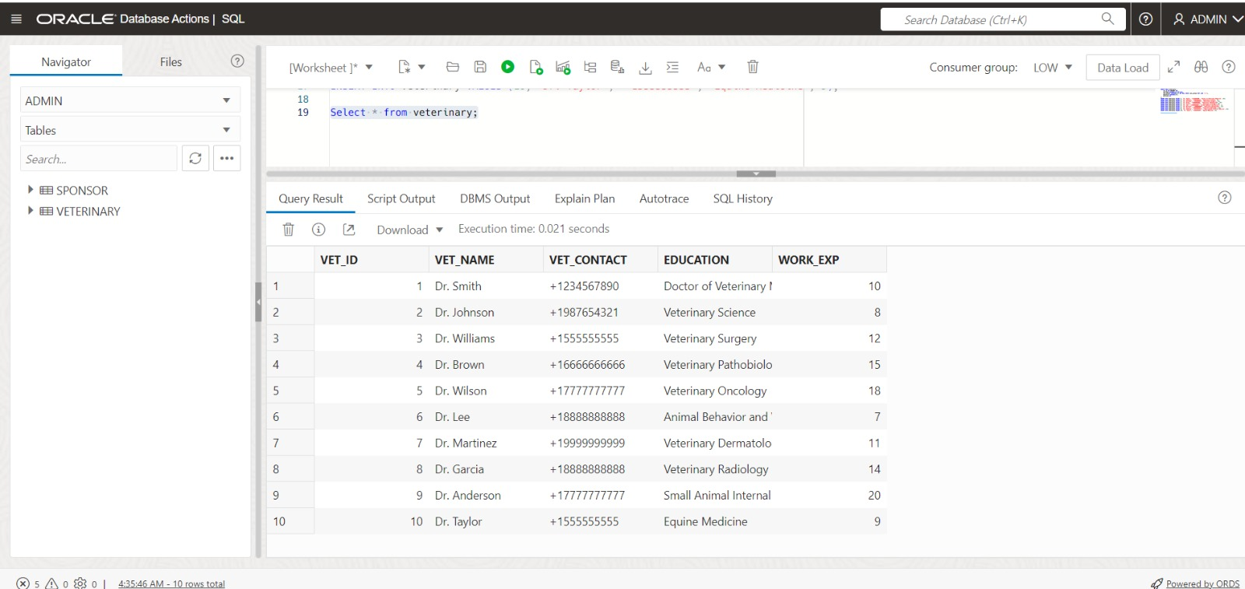

**Creating a table named nutrition**

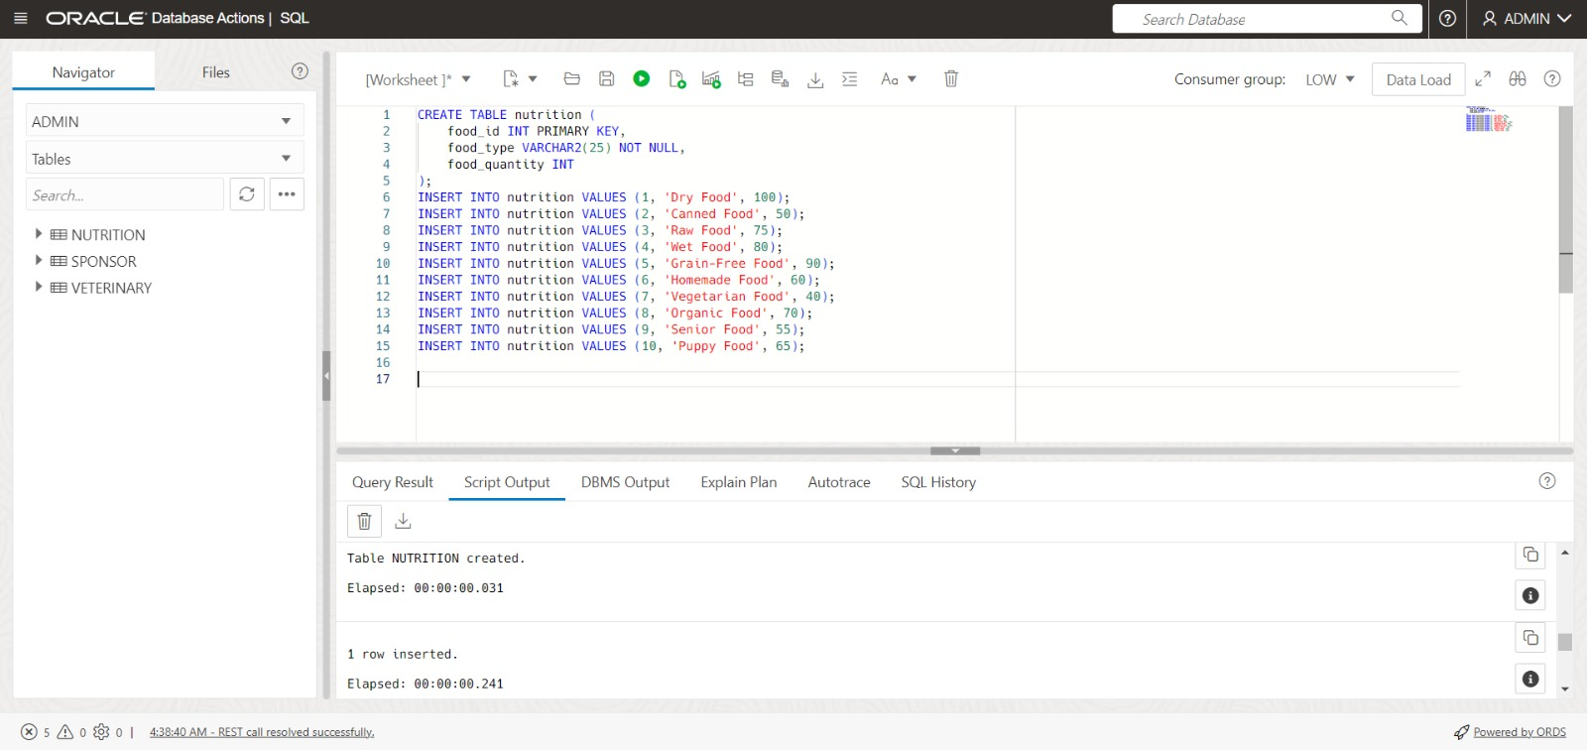

**Inserting values to nutrition**

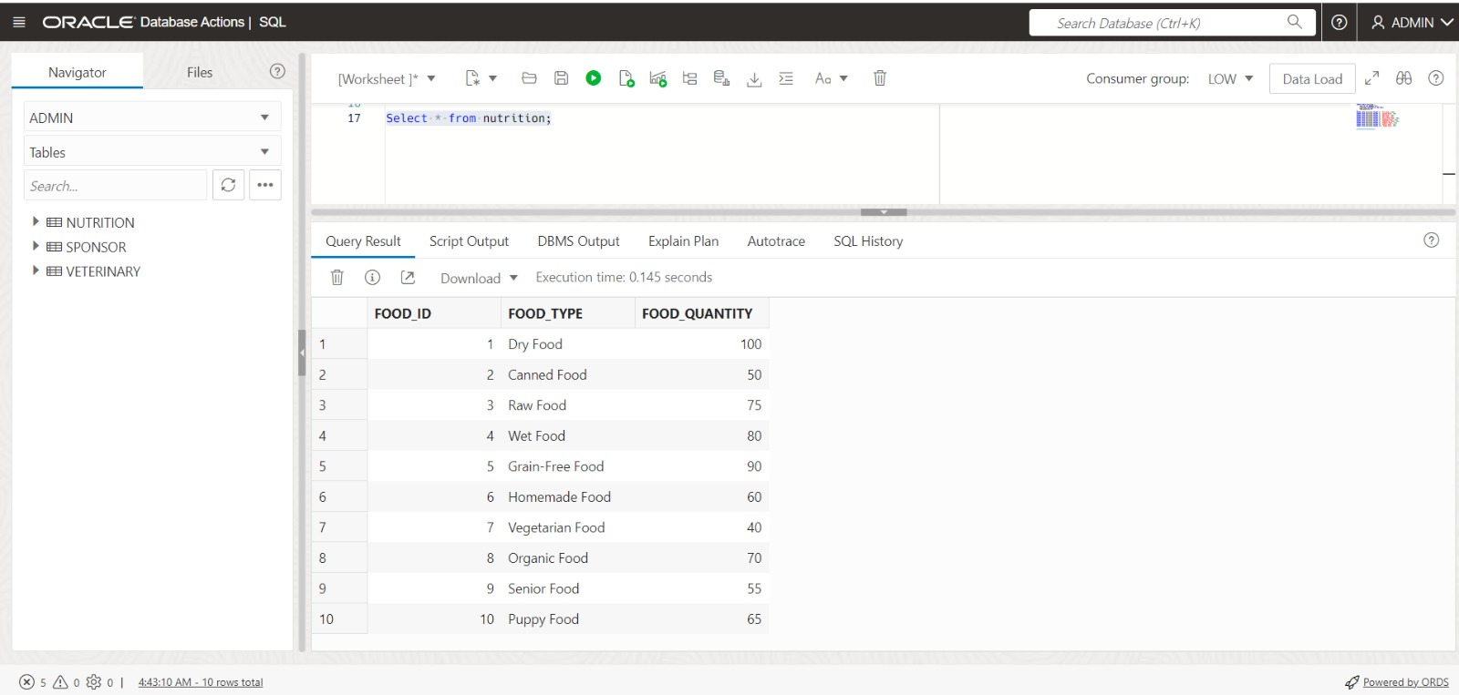

**Creating a table named vaccination**

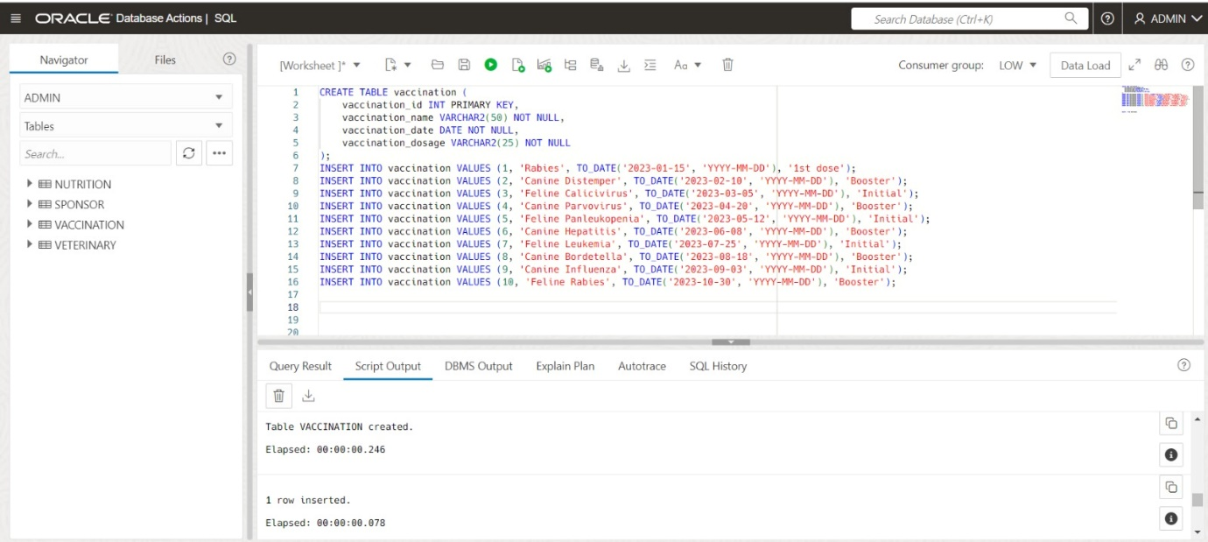

**Inserting values to vaccination**

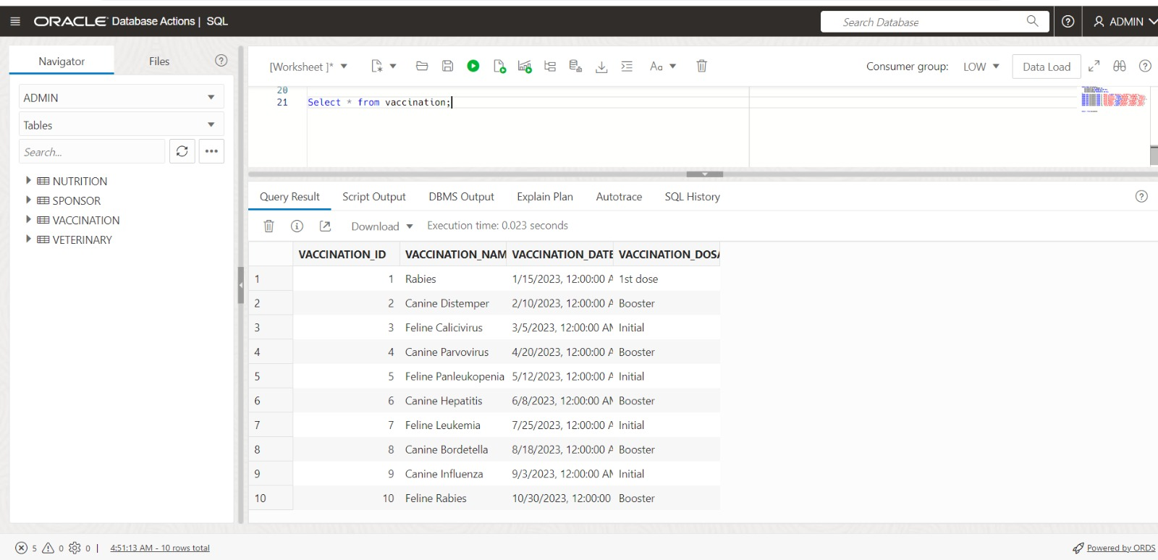

**Creating a table named shelter_branch**

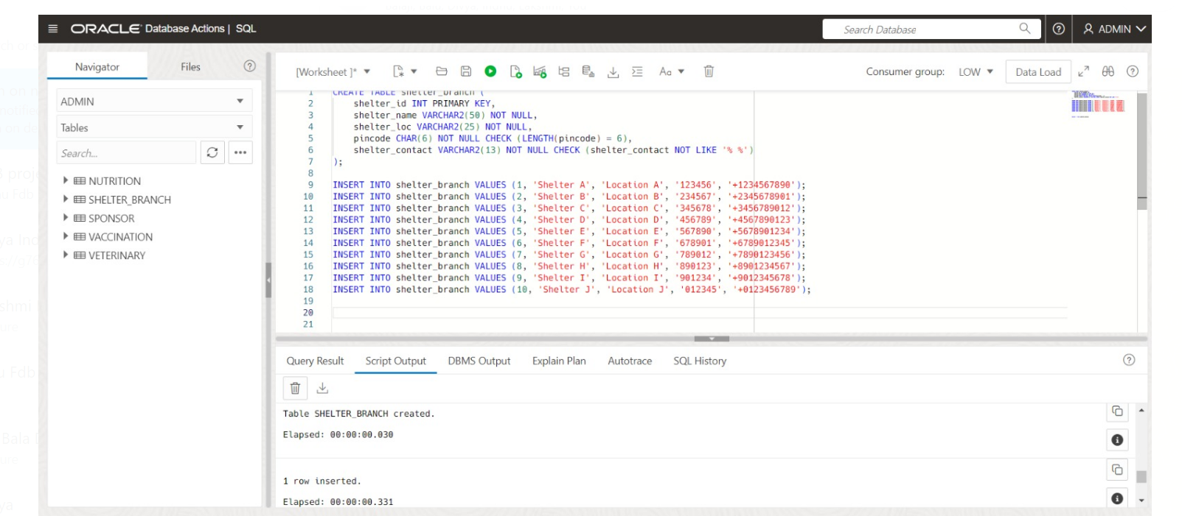

**Inserting values to shelter_branch**

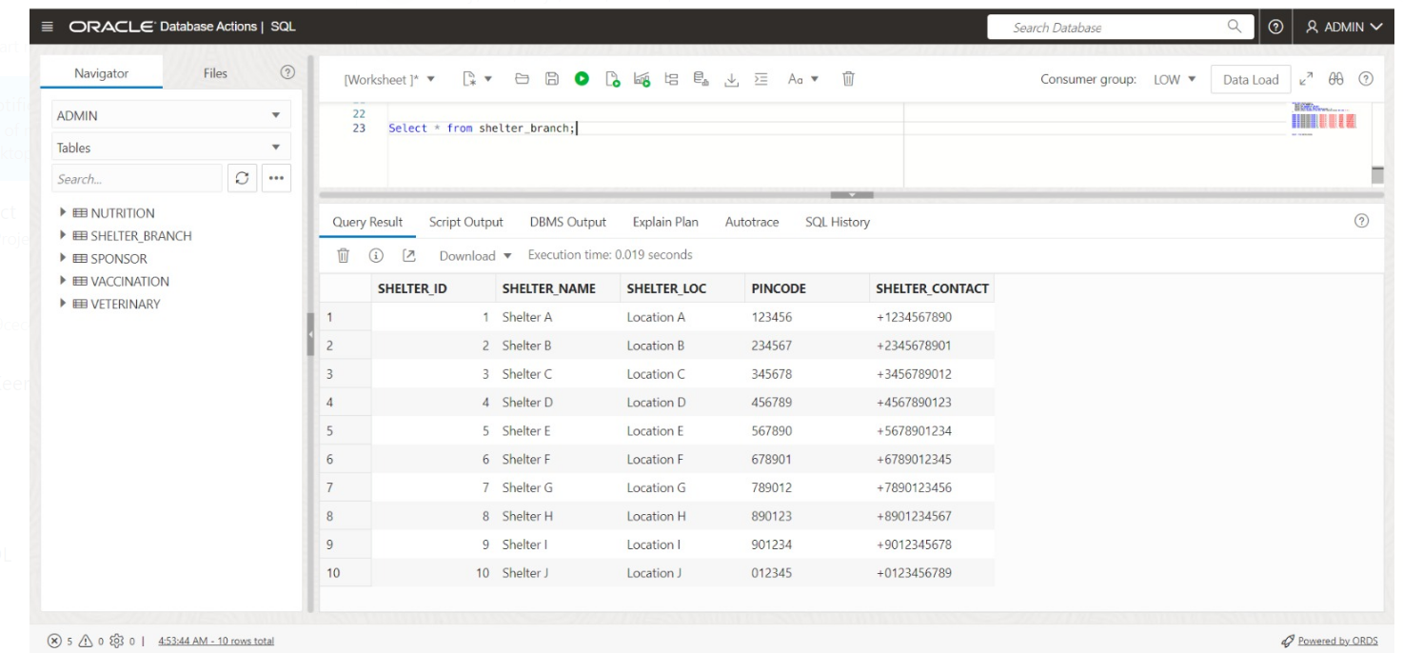

**Creating a table named animal_features**

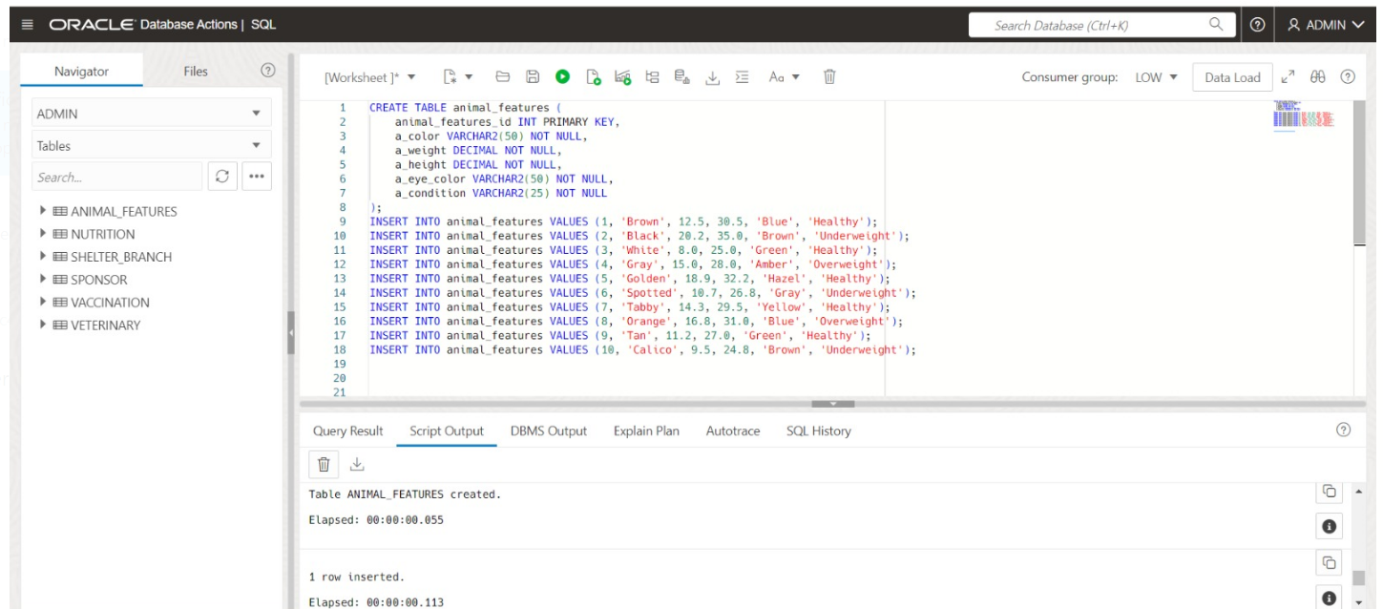

**Inserting values to animal_features**

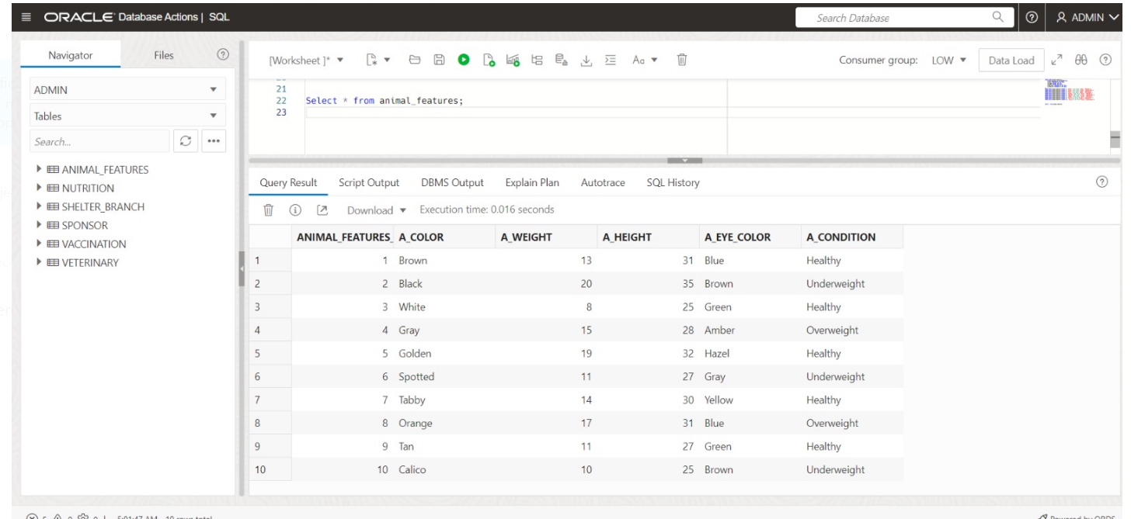

**Creating a table named facilities**

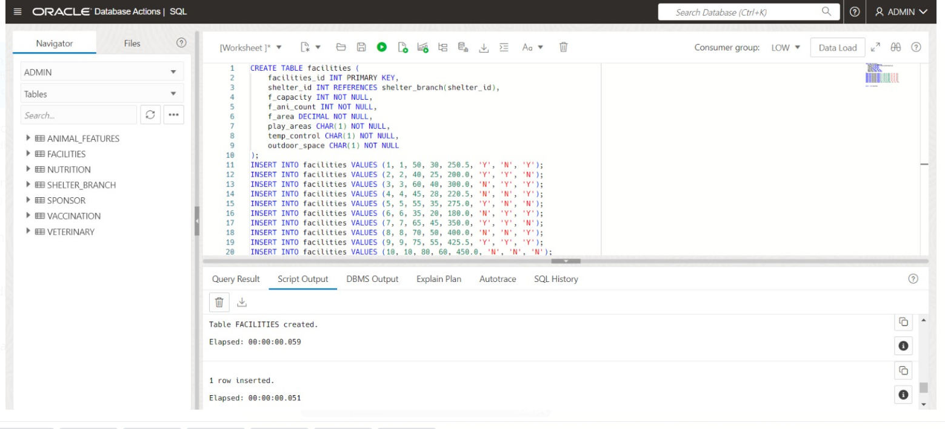

**Inserting values to facilities**

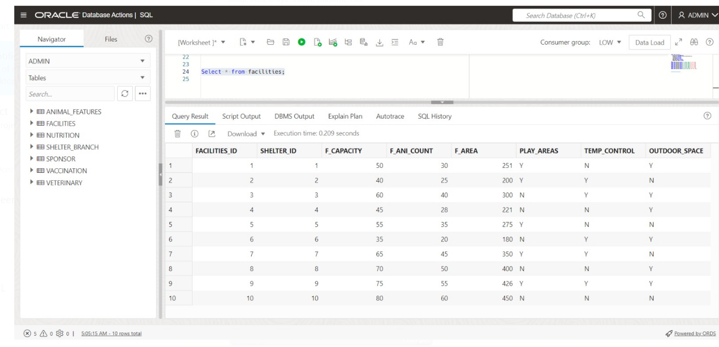

**Creating a table named medical_history**

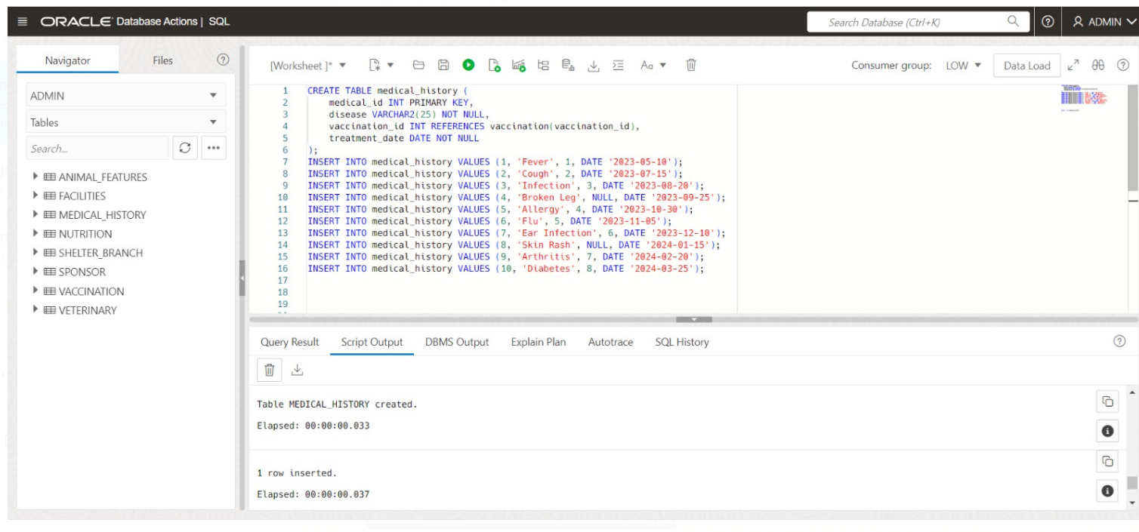

**Inserting values to medical_history**

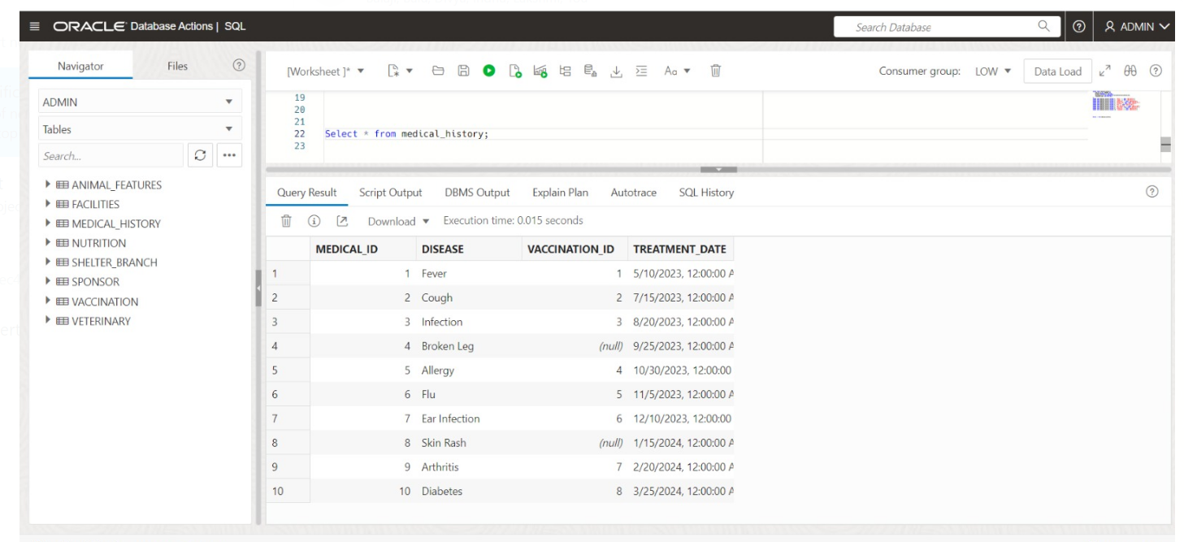

**Creating a table named adoption_details**

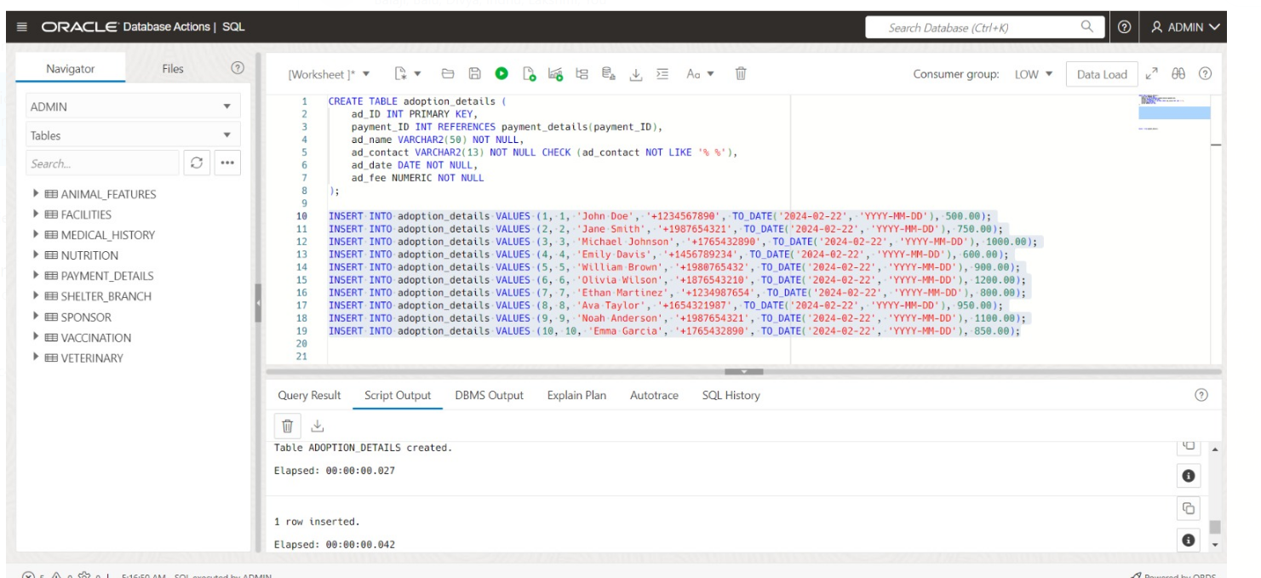

**Inserting values to adoption_details**

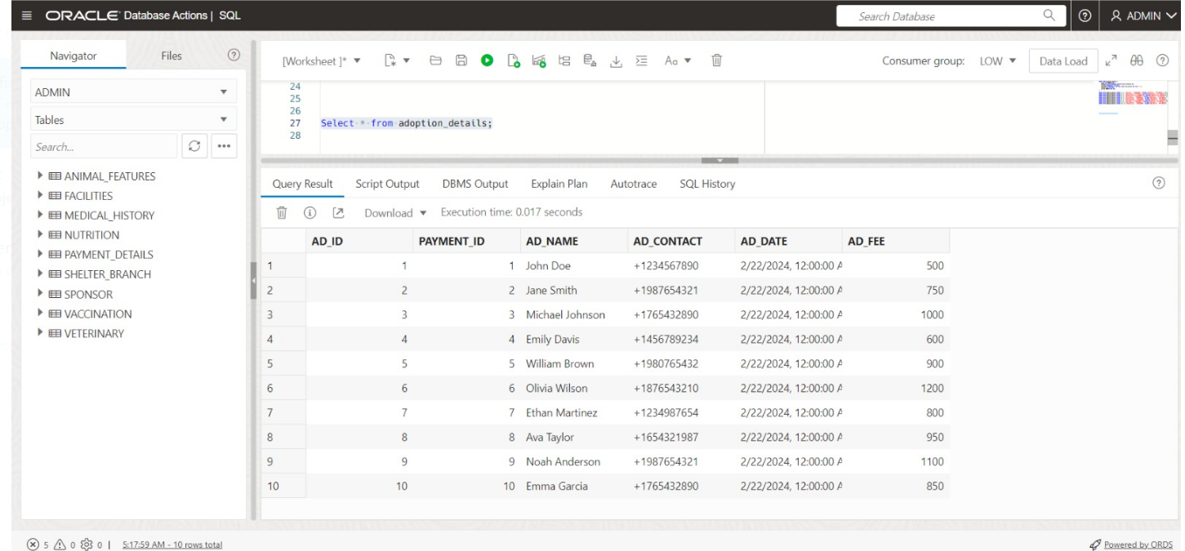

**Creating a table named surrender_details**

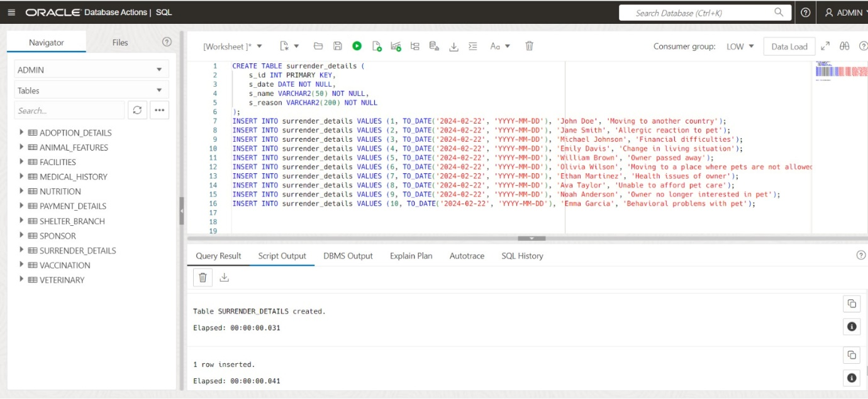

**Inserting values to surrender_details**

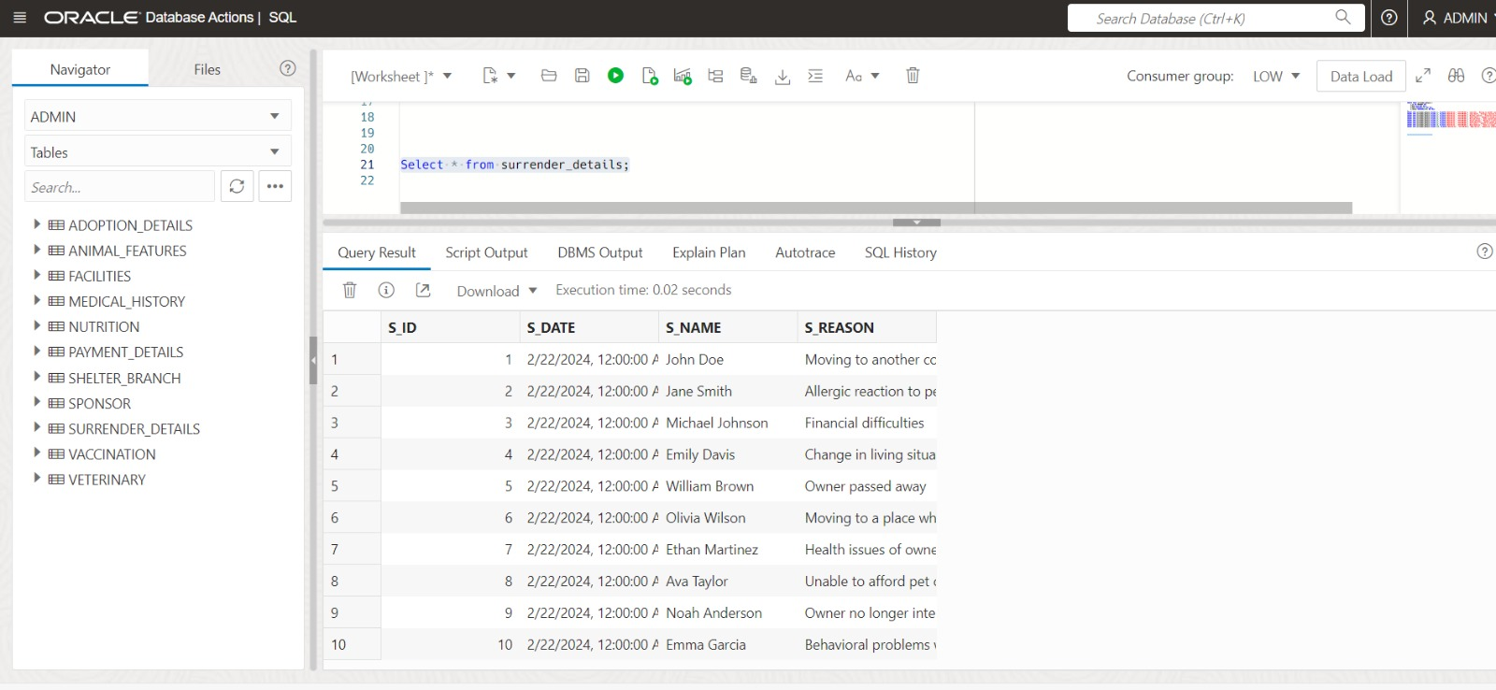

**Creating a table named payment_details**

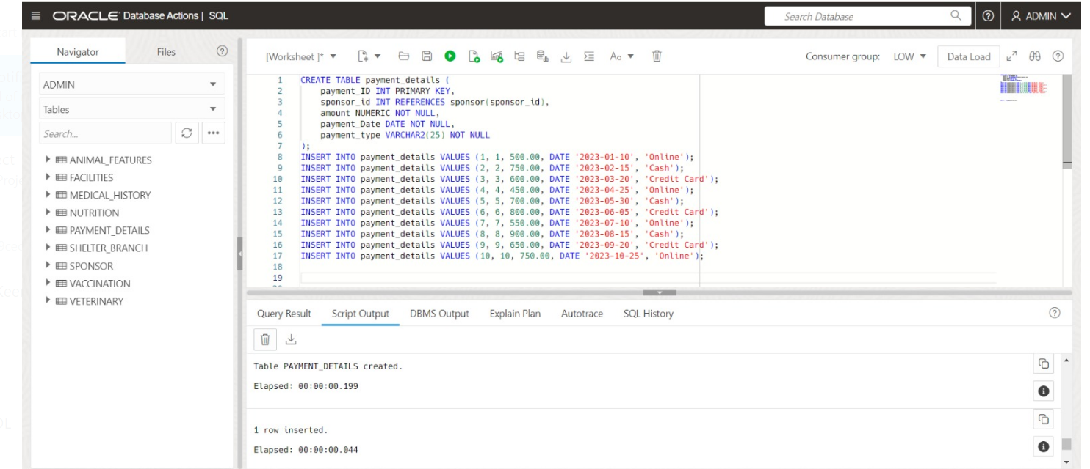

**Inserting values to payment_details**

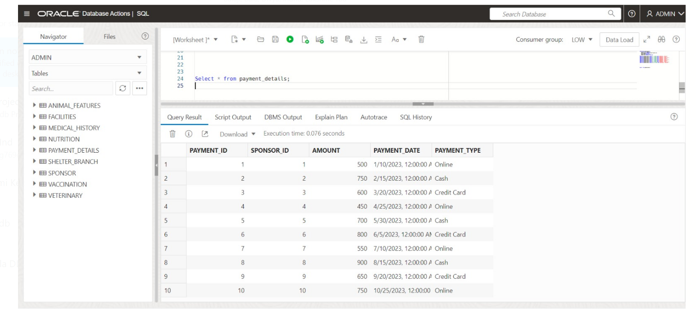

**Creating a table named training_history**

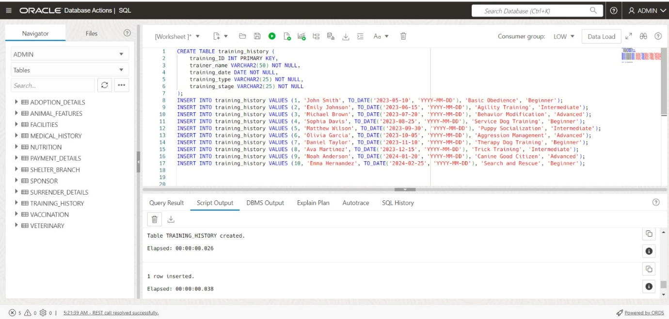

**Inserting values to training_history**

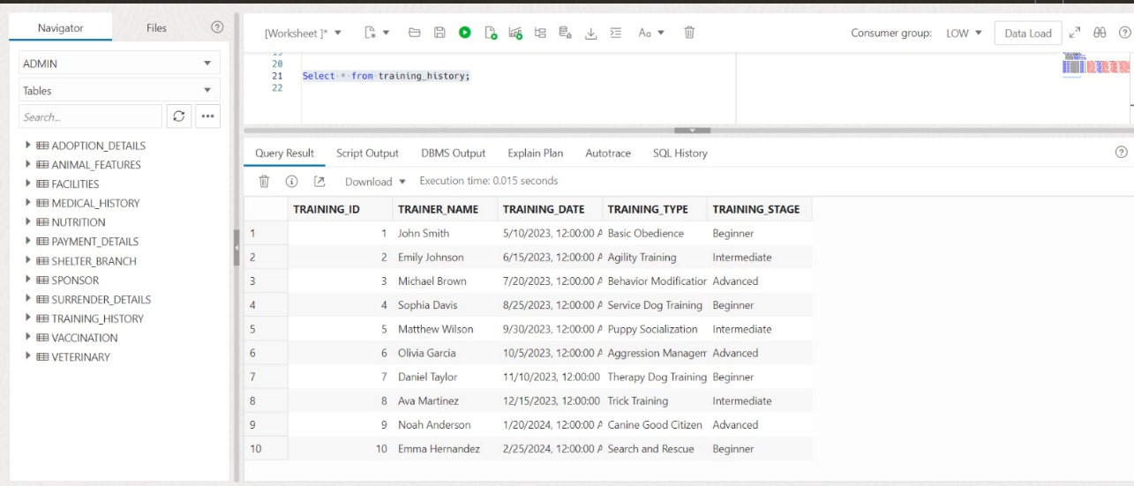

**Creating a table named grooming_history**

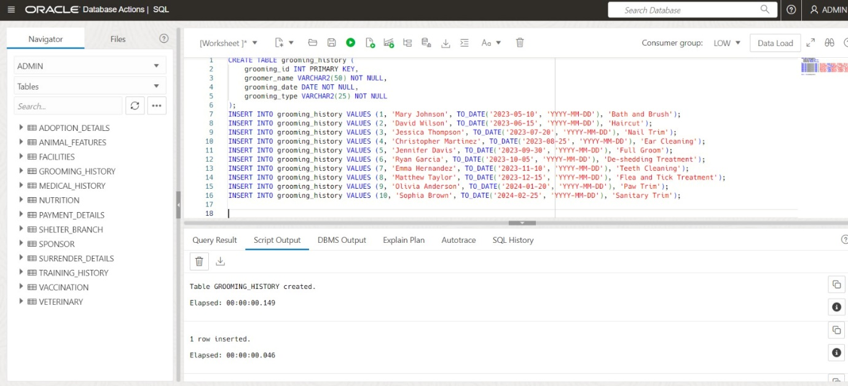

**Inserting values to grooming_history**

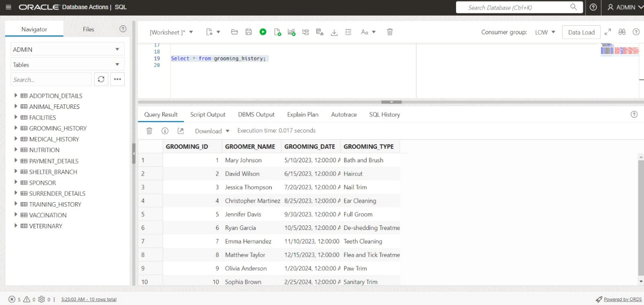

**Creating a table named employees_staff_details**

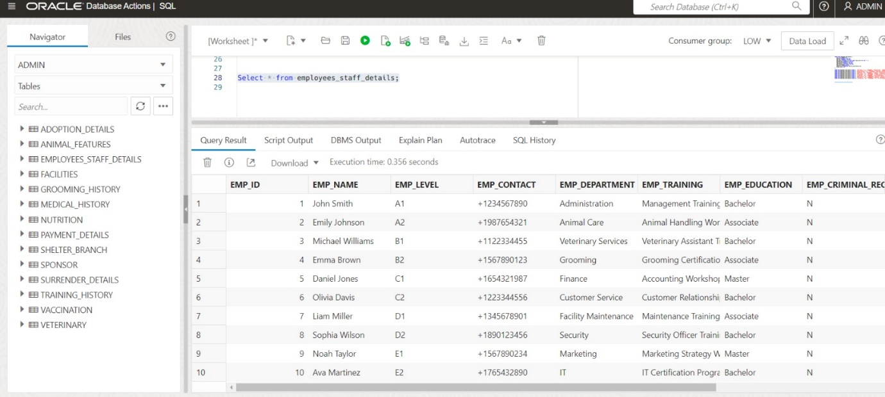

**Inserting values to employees_staff_details**



**Creating a table named animal_info**

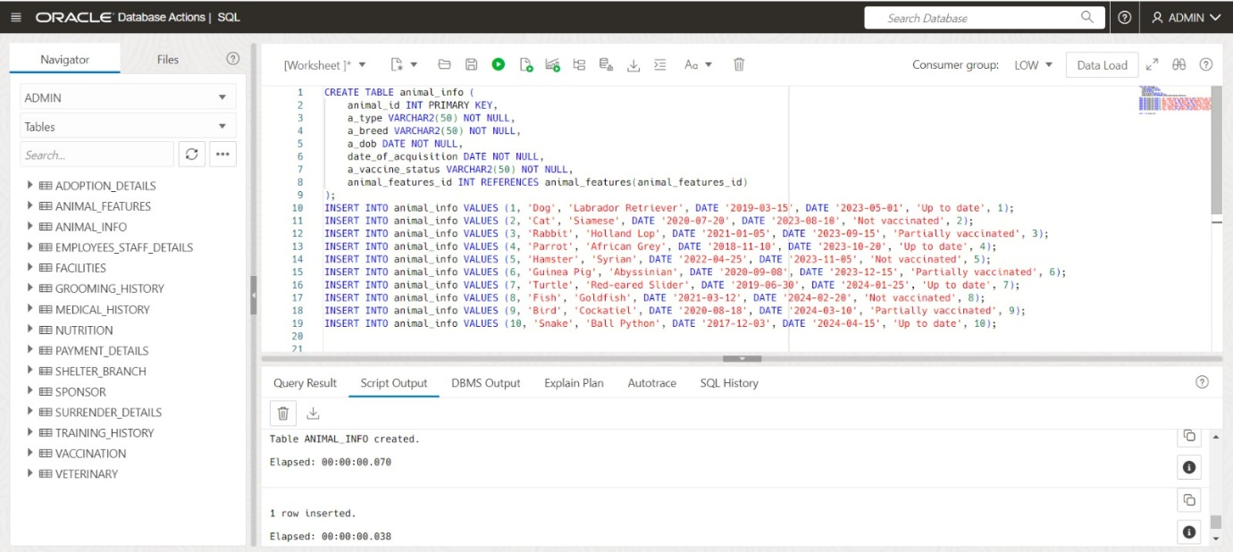

**Inserting values to animal_info**

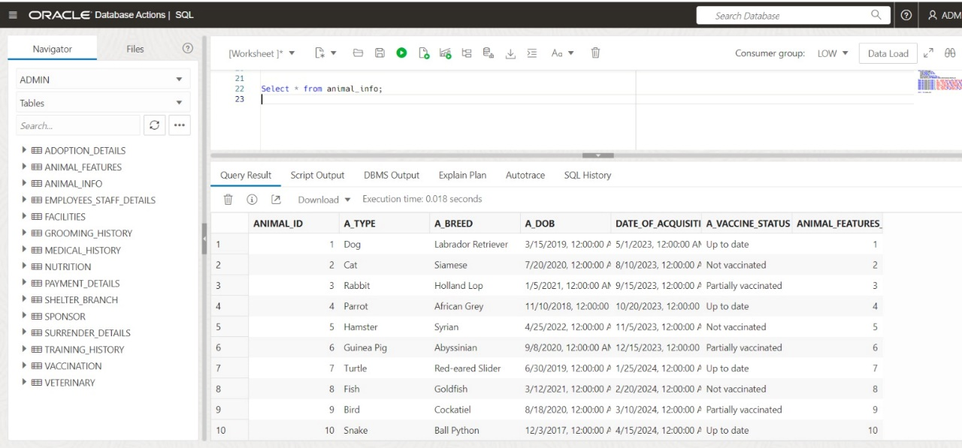

**Creating a table named transfers**

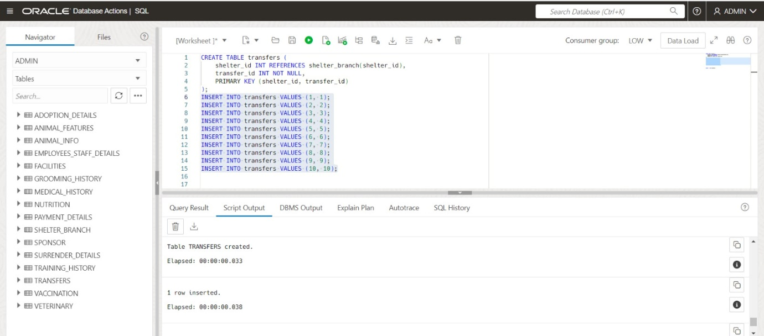

**Inserting values to transfers**

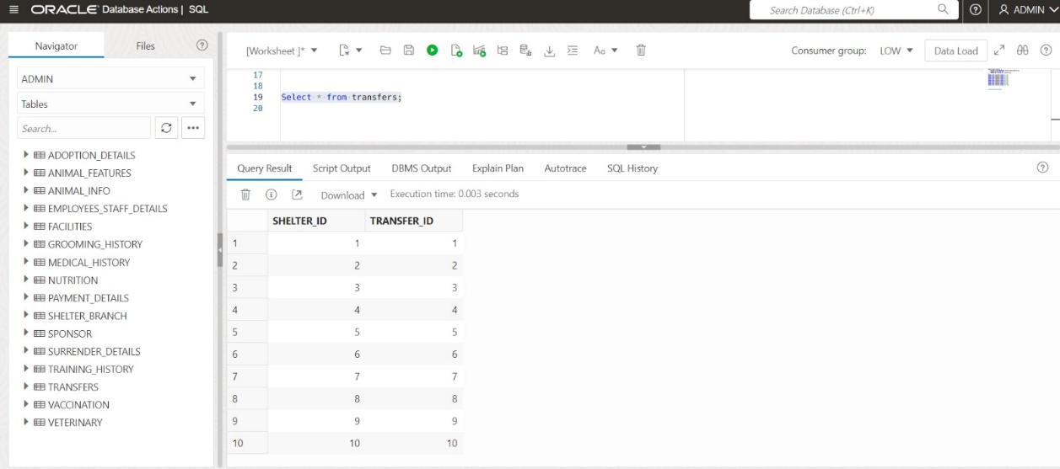

**Creating a table named animal_transfer_records**

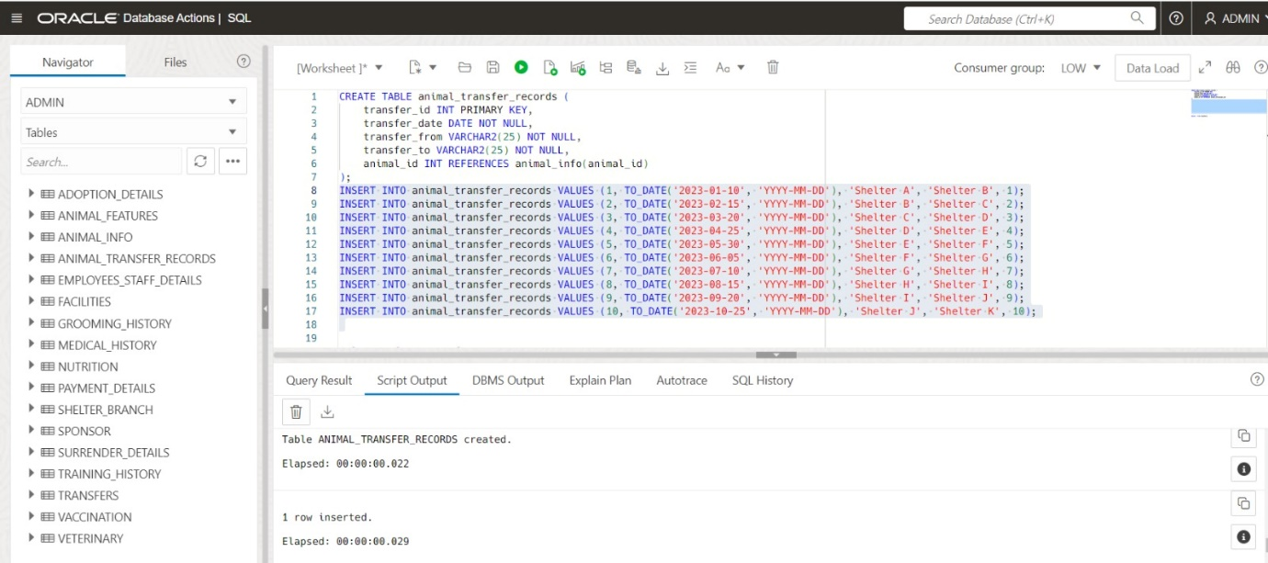

**Inserting values to animal_transfer_records**

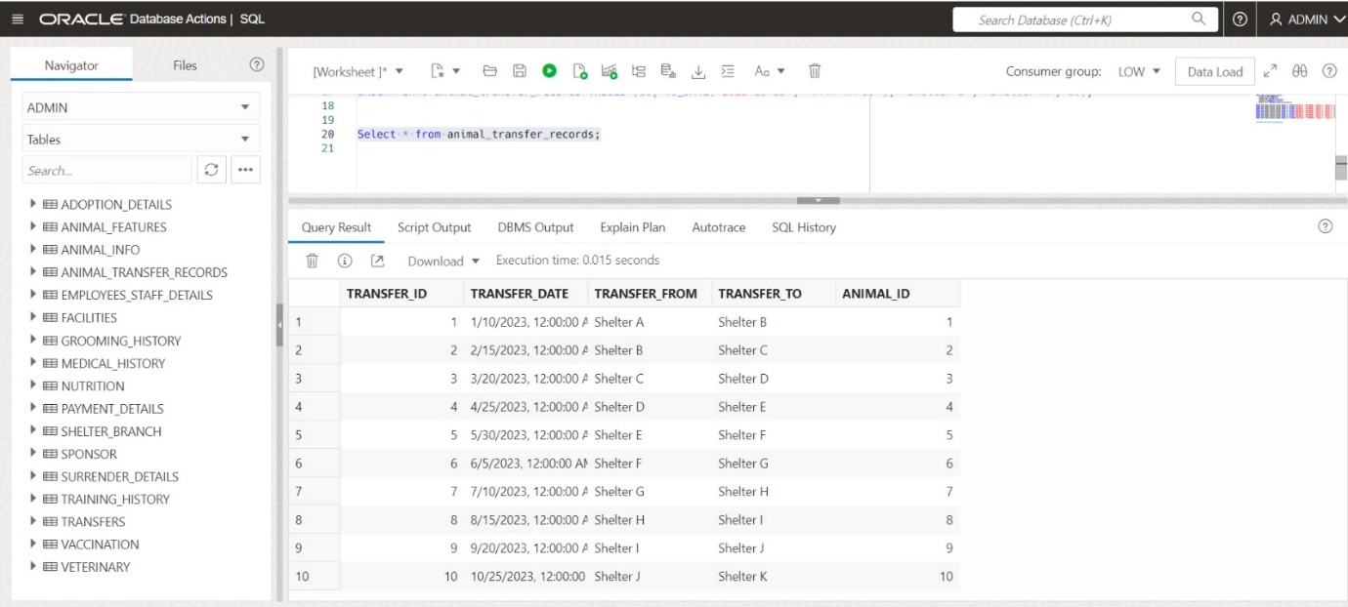

**Creating a table named employee_payroll**

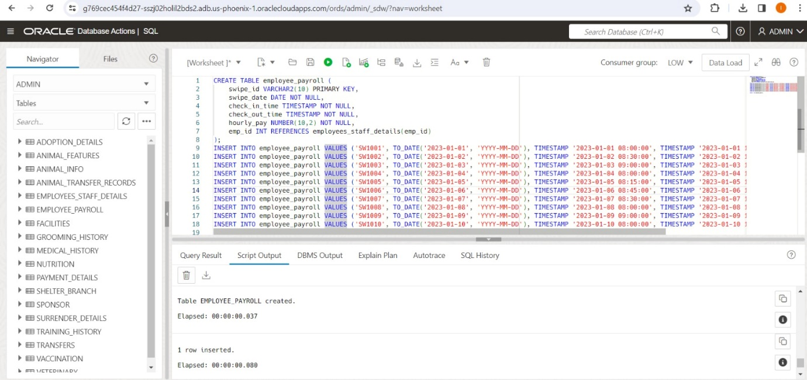

**Inserting values to employee_payroll**

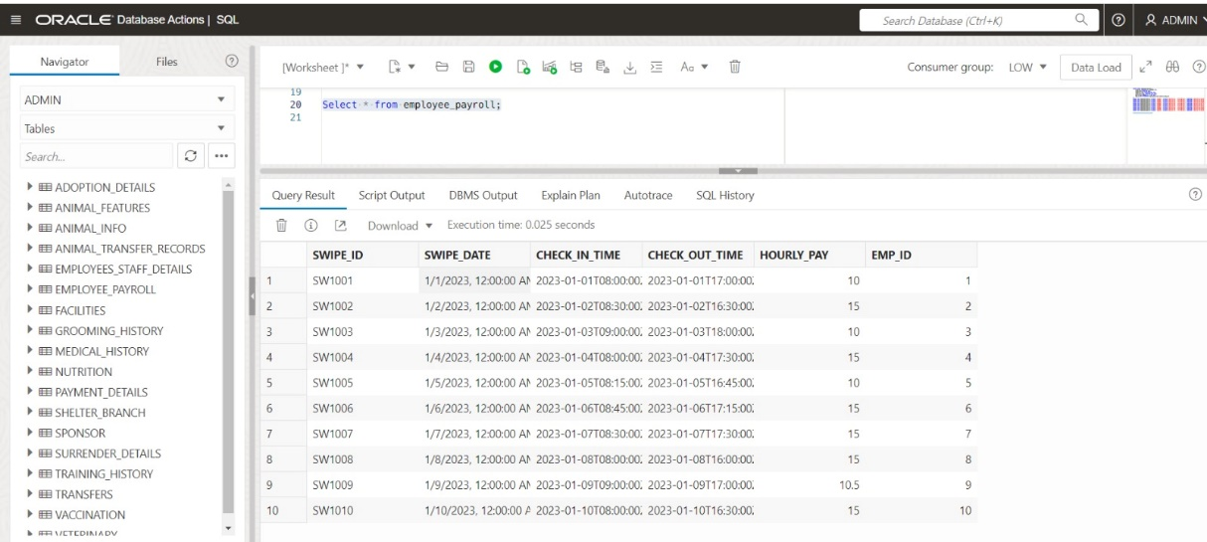

**Creating a table named support**

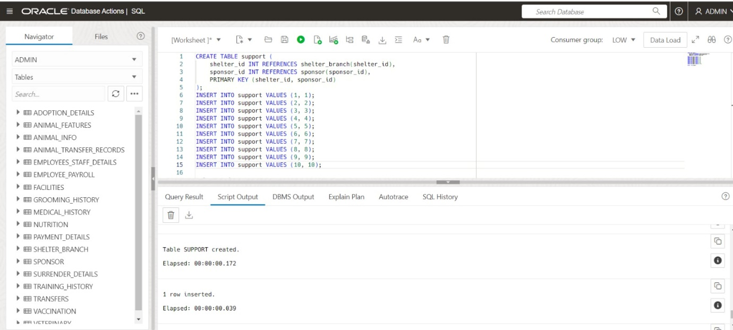

**Inserting values to support**

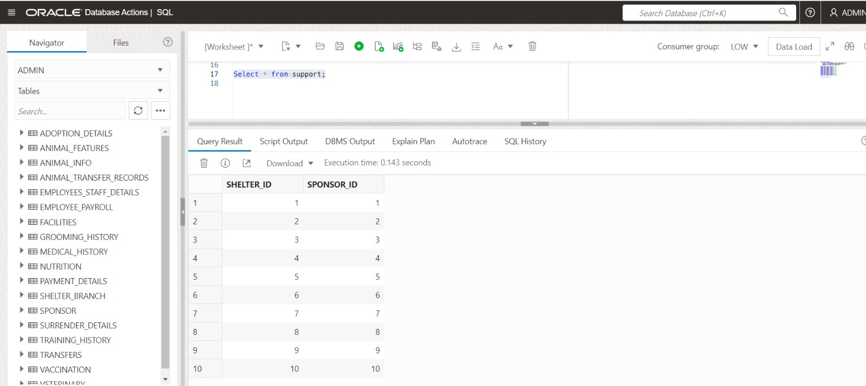

**Creating a table named animal_info**

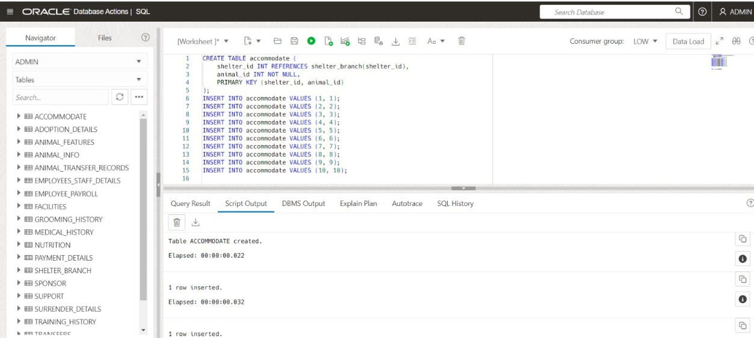

**Inserting values to animal_info**

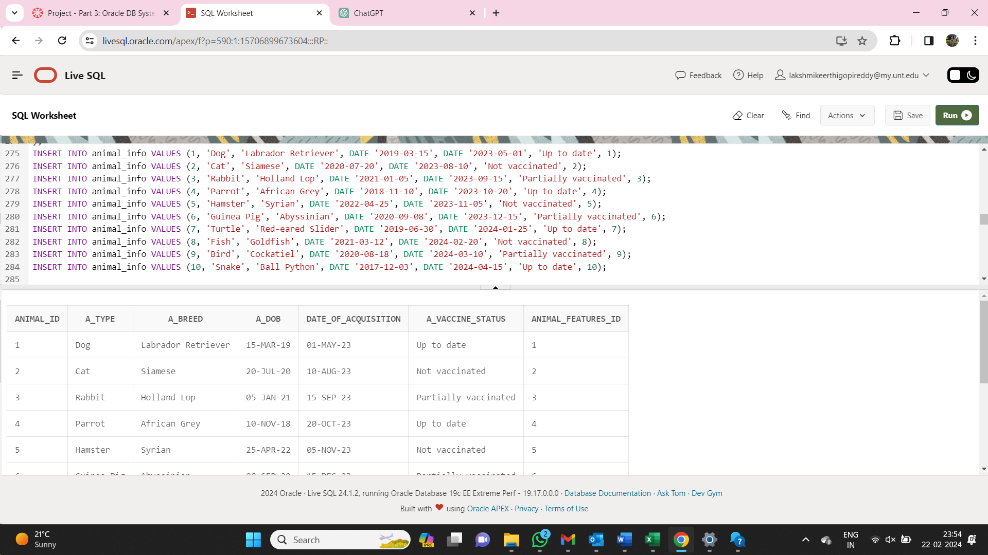

**Creating a table named accommodate**

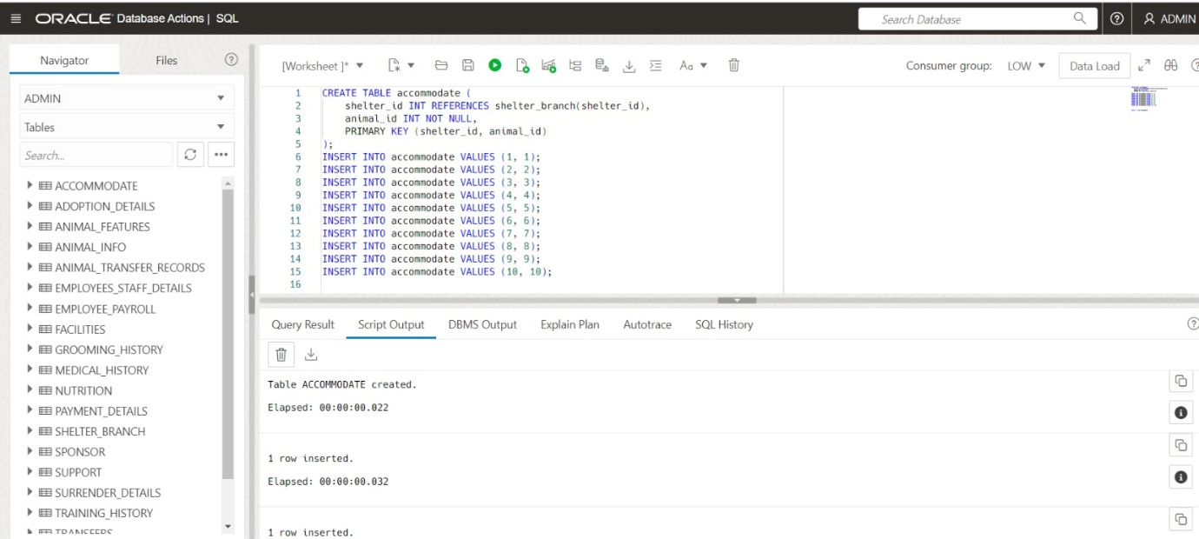

**Inserting values to accommodate**

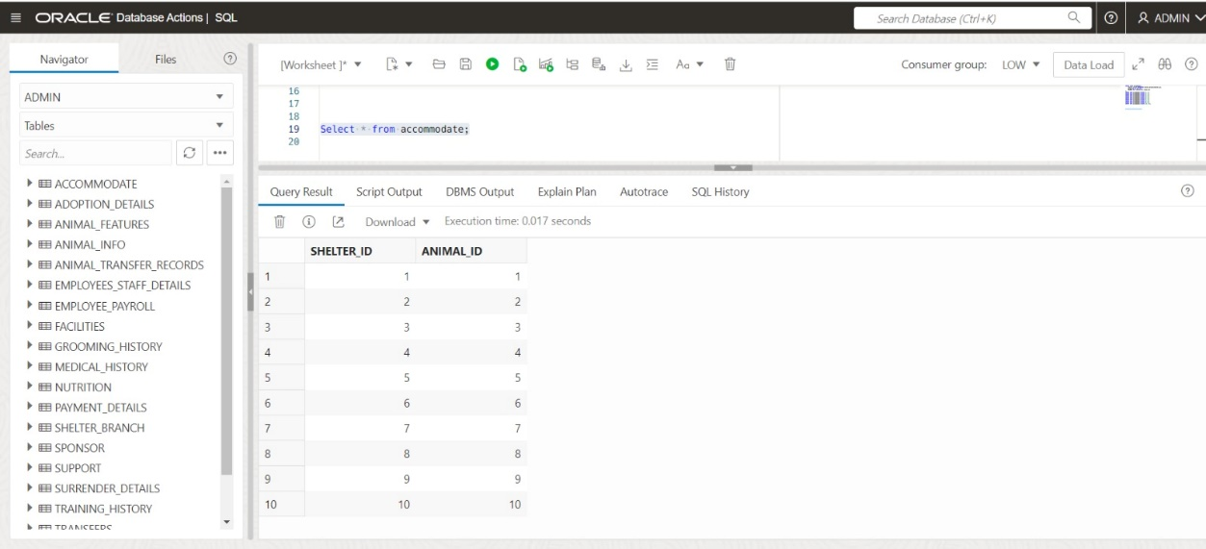

**Creating a table named contain**

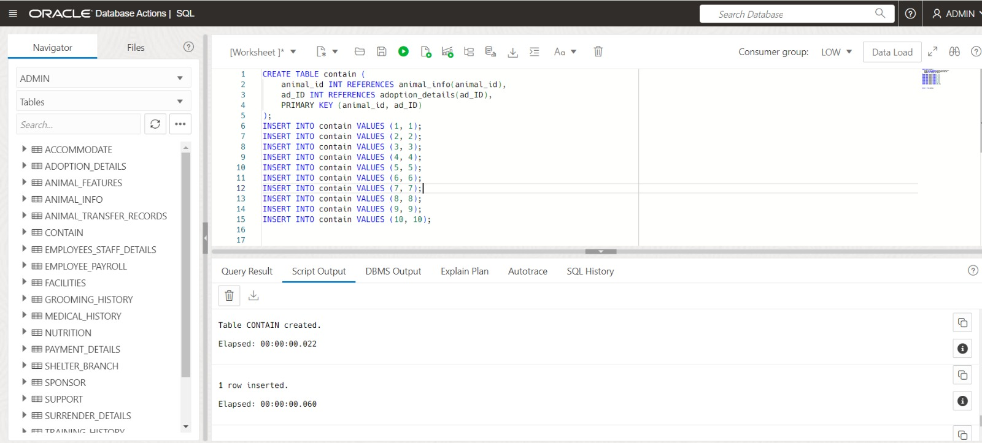

**Inserting values to contain**

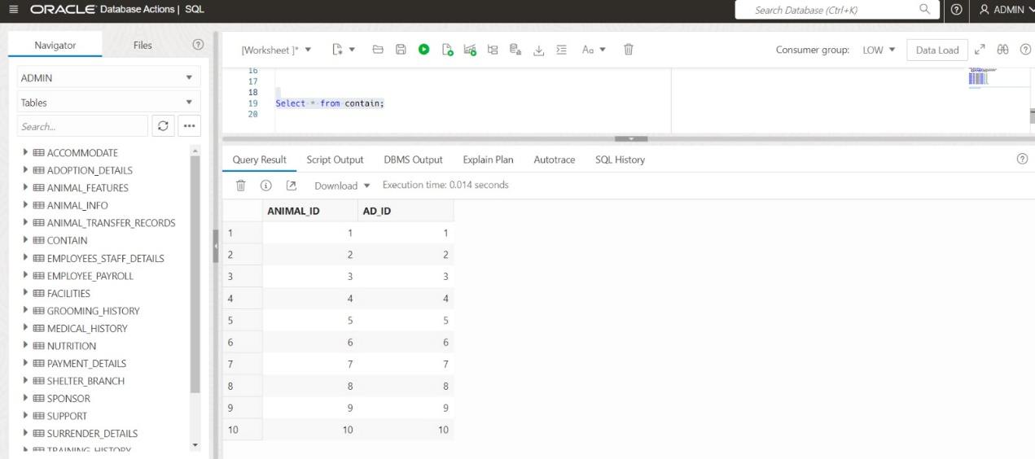

**Creating a table named submit**

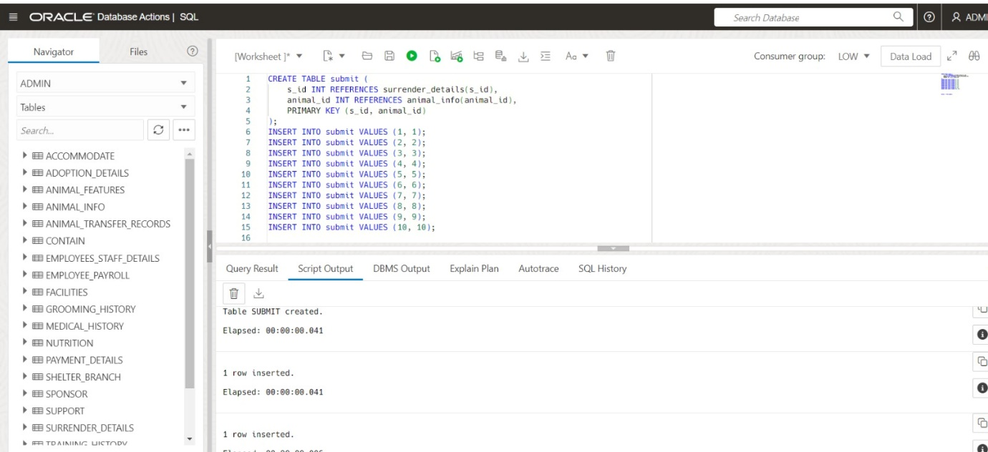

**Inserting values to submit**

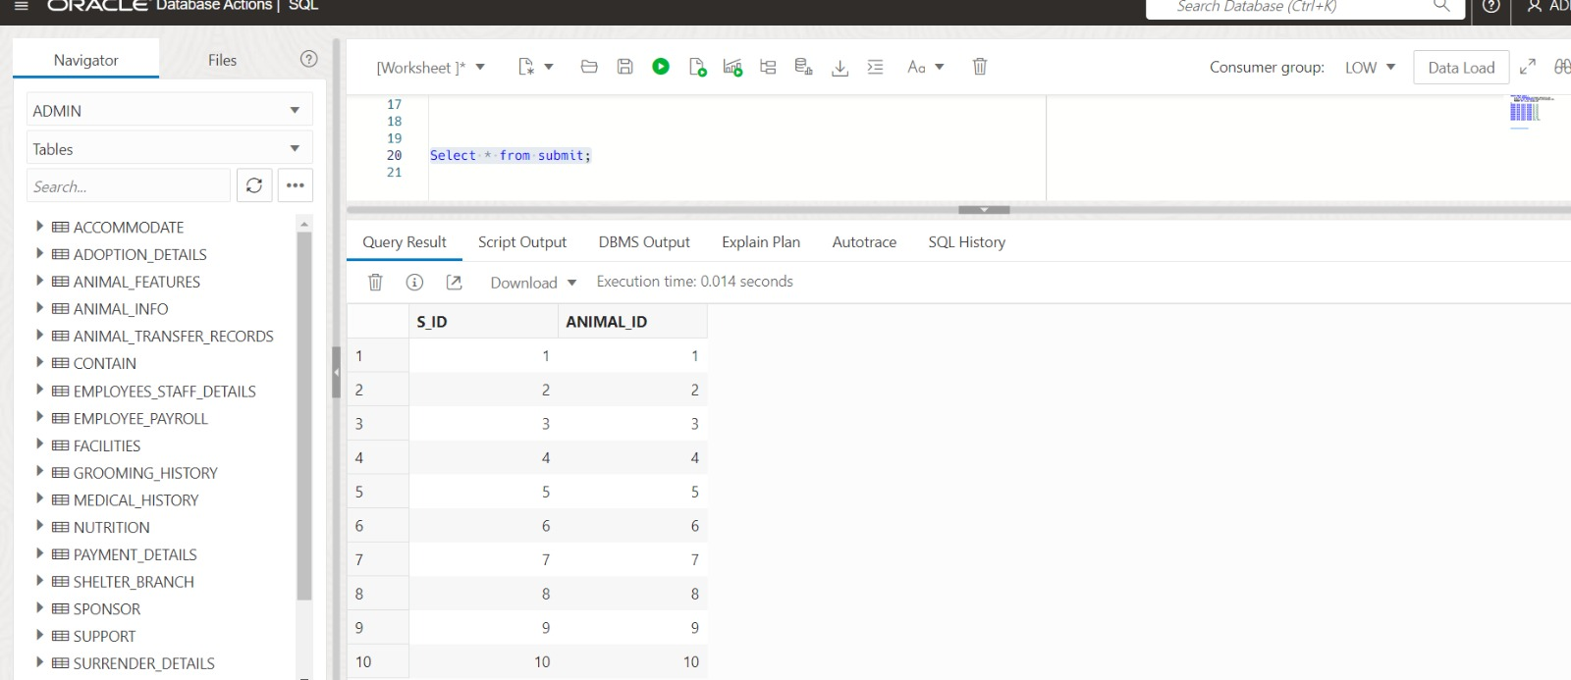

**Creating a table named need**

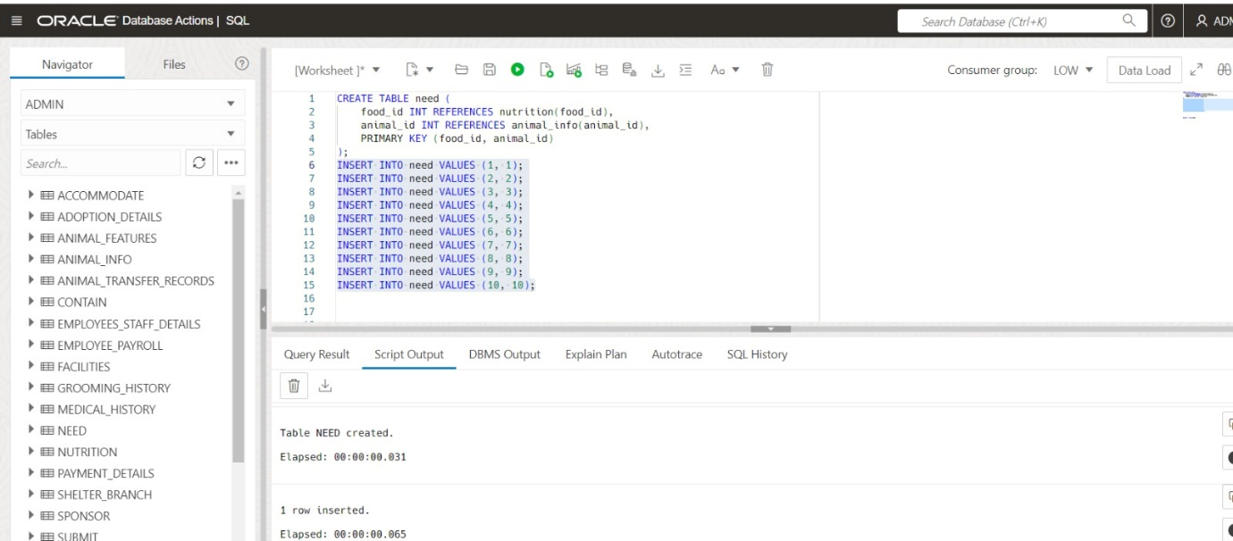

**Inserting values to need**

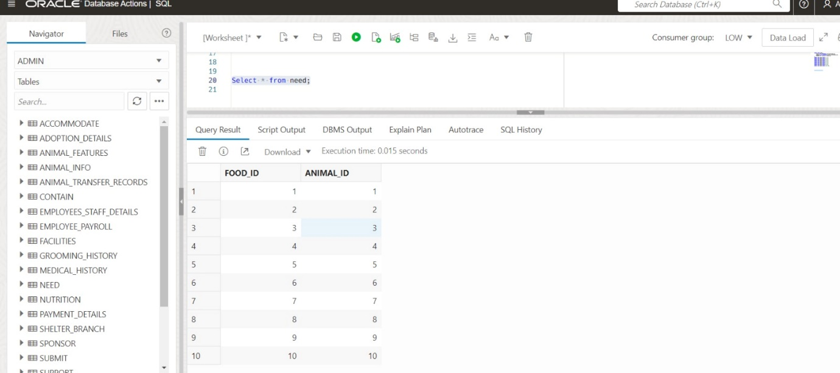

**Creating a table named done_by**

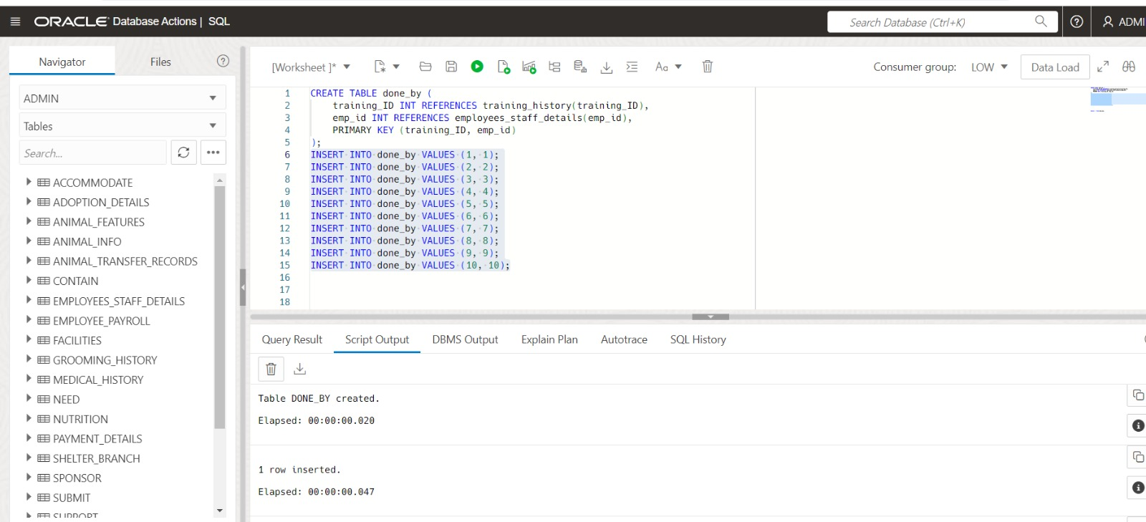

**Inserting values to done_by**

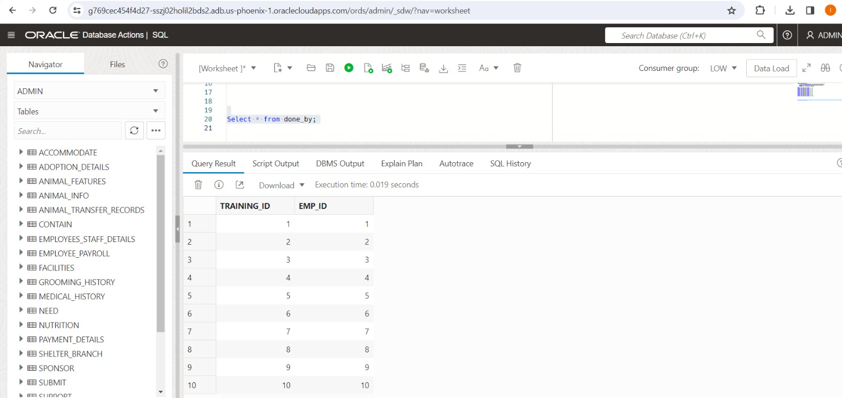

**Creating a table named perform**

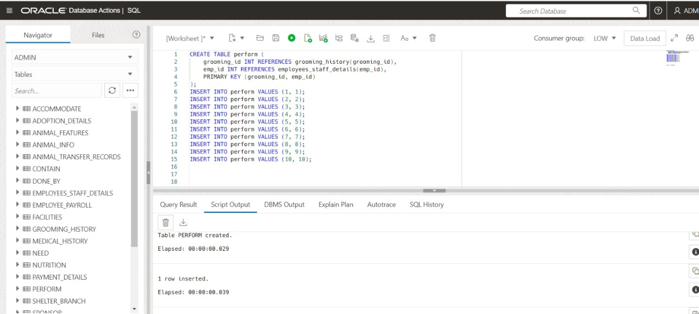

**Inserting values to perform**

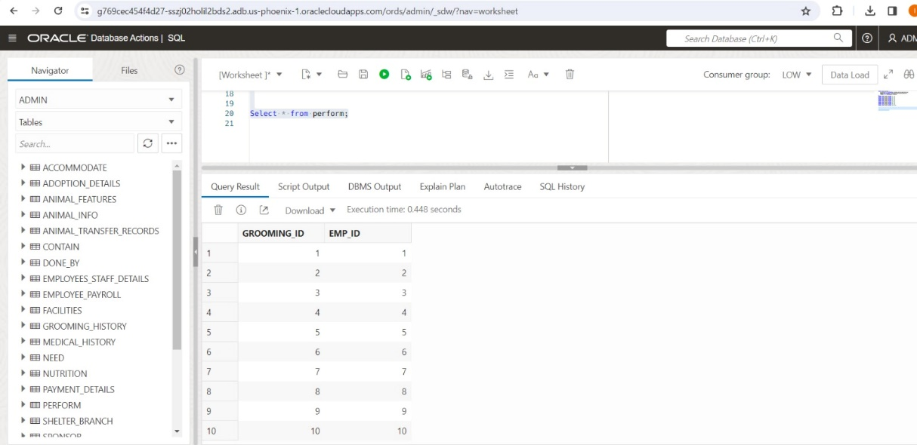

**Creating a table named examine**

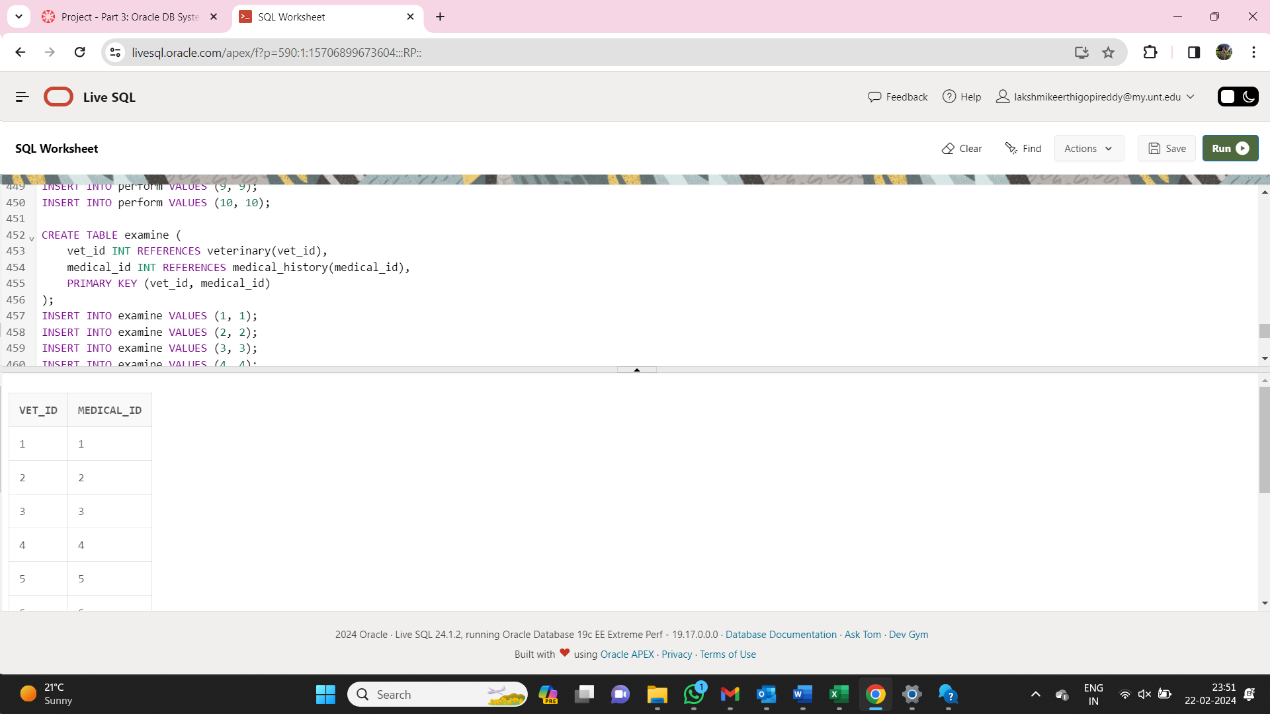

**Inserting values to examine**

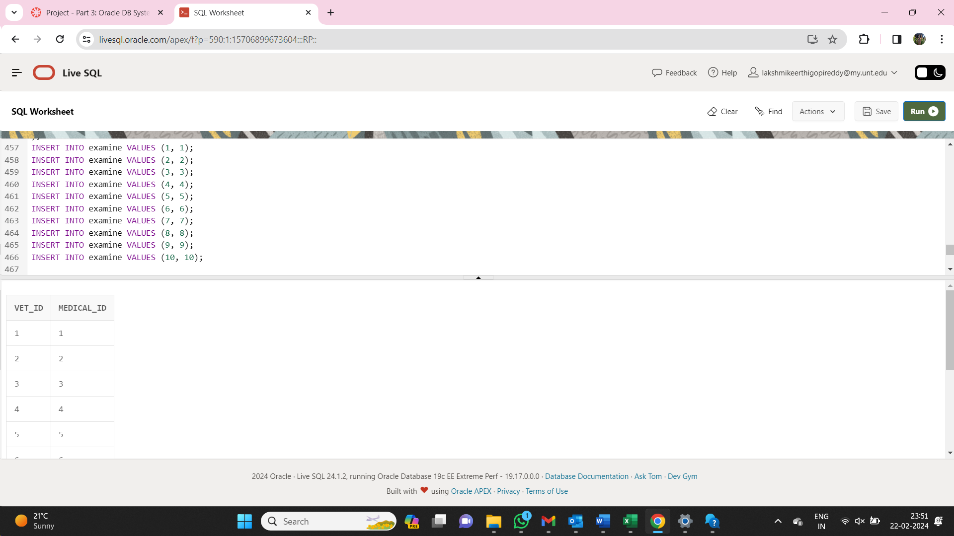

**Creating a table named veterinary_specialization**

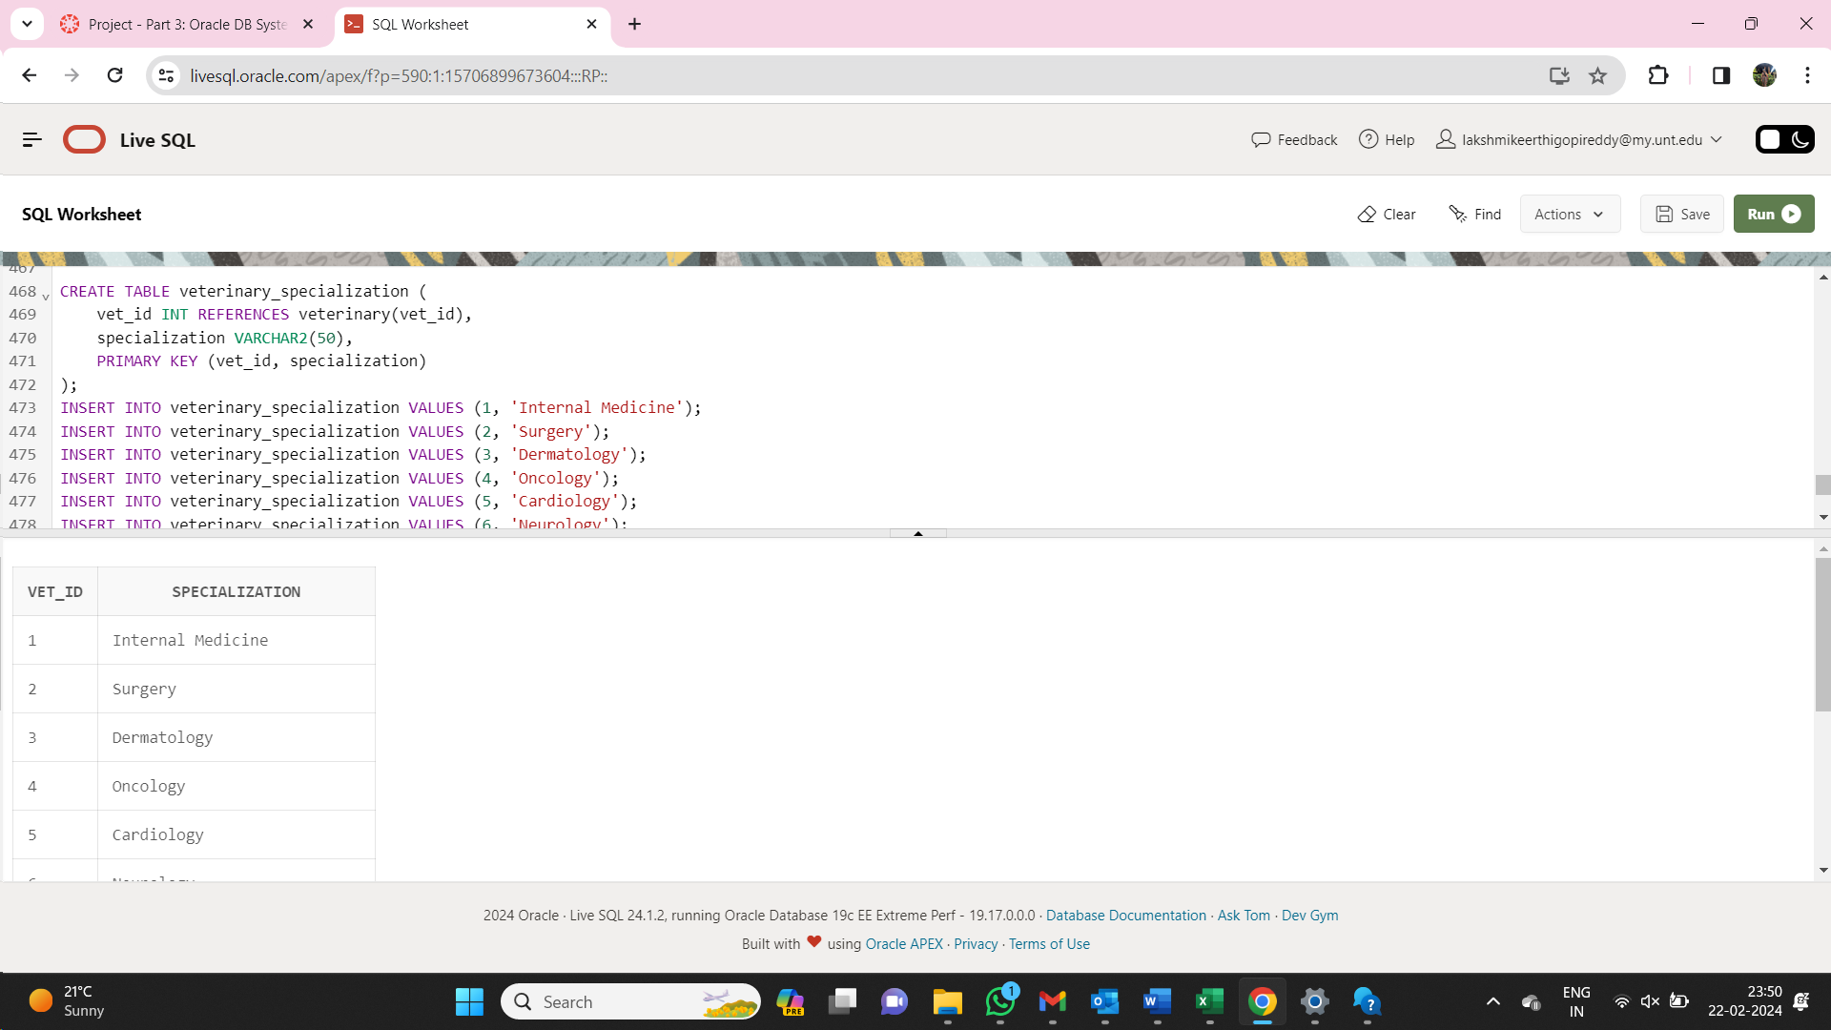

**Inserting values to veterinary_specialization**

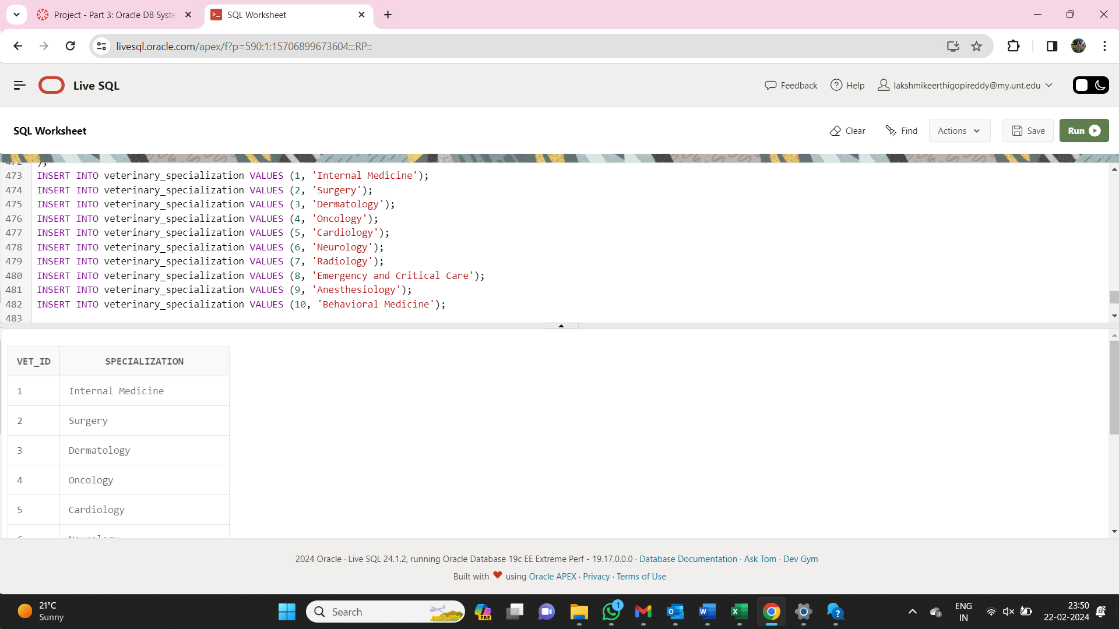

**Creating a table named stores**

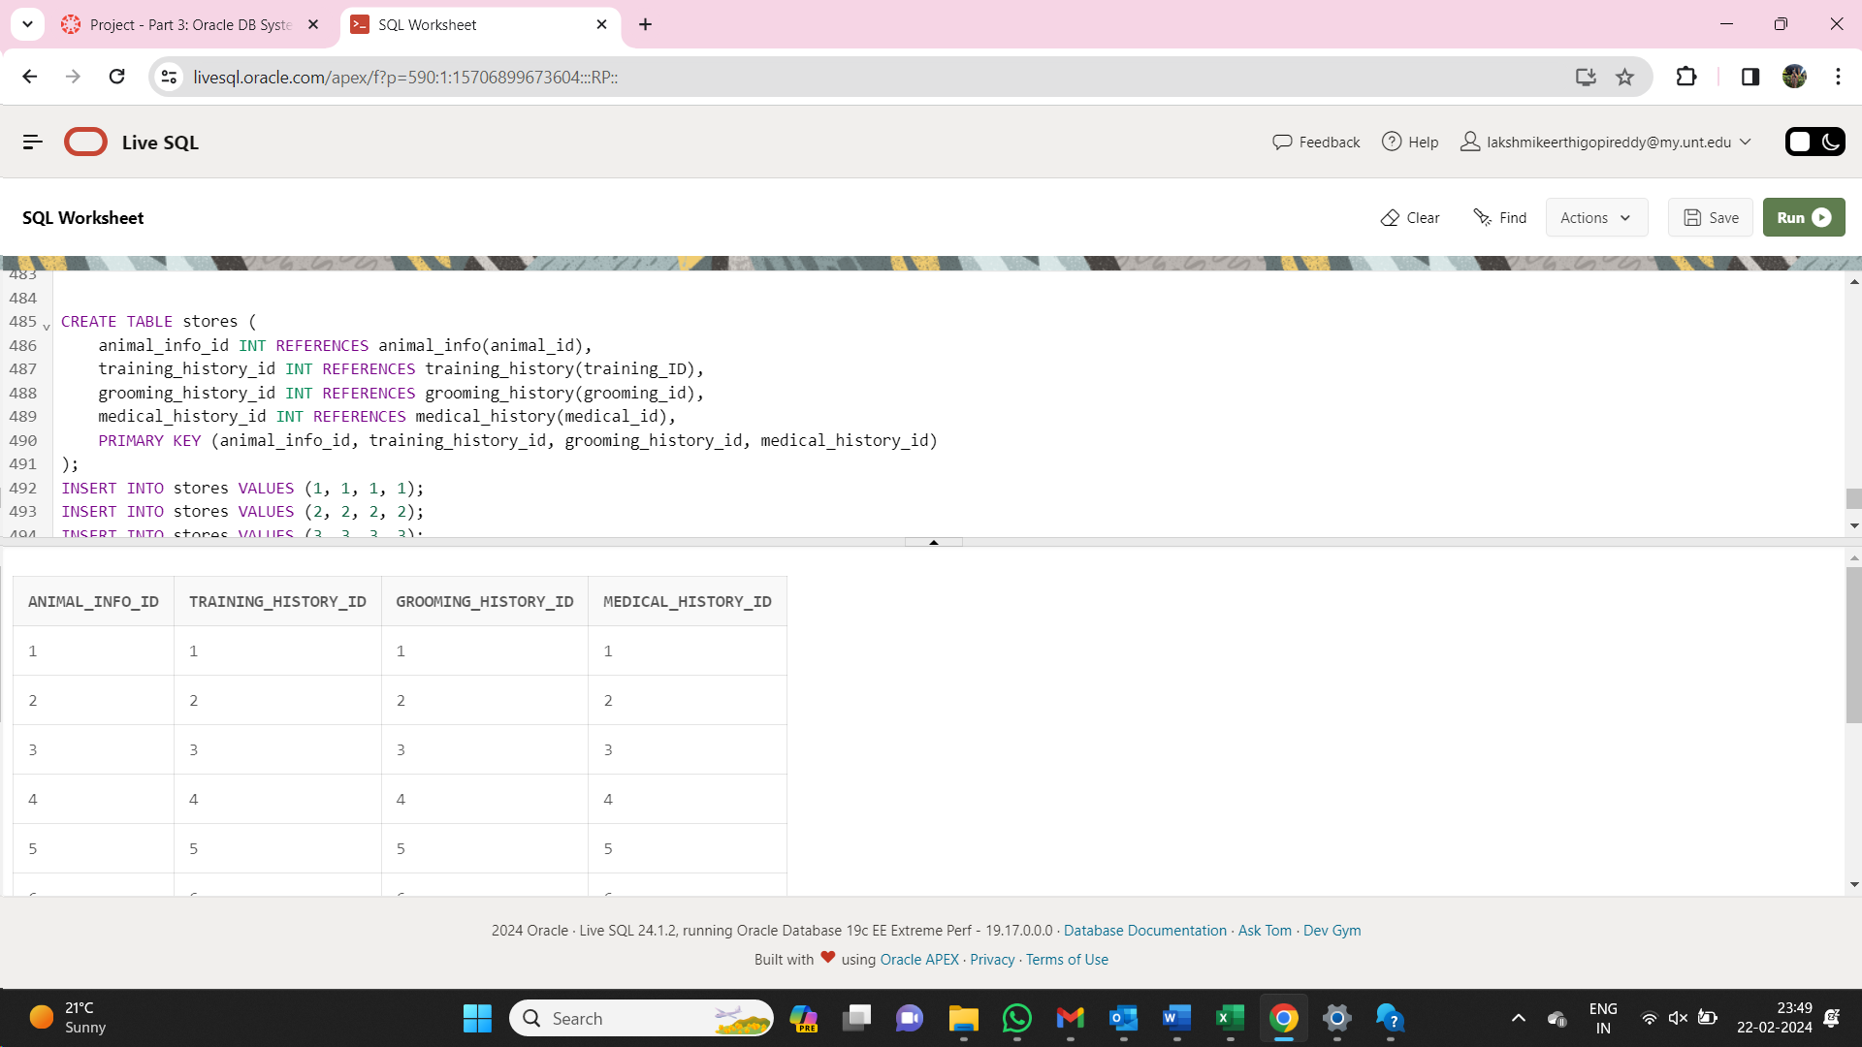

**Inserting values to stores**

